**Project 1**

1. Access key

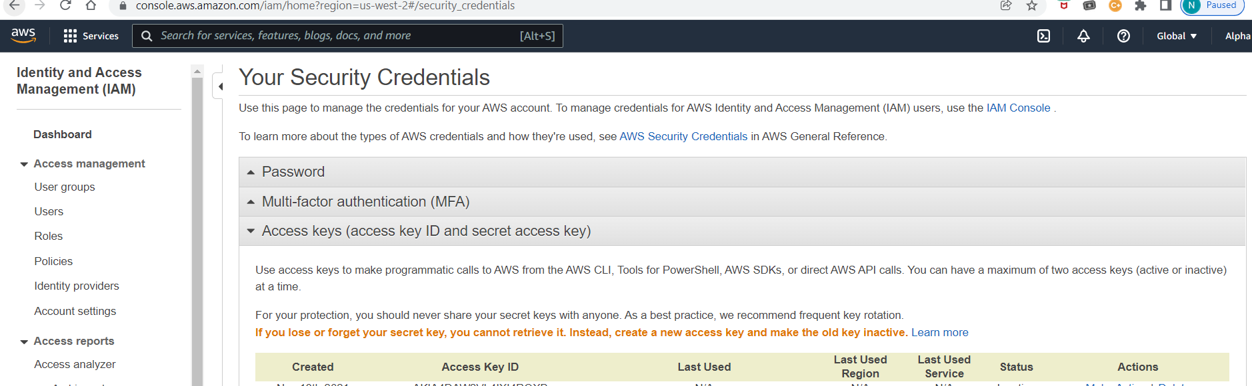

1. Creating 2 servers: 1 for Ansible & other for Jenkins using Terraform:



1. Execute Terraform init, Plan & apply for Ansible Server Creation:

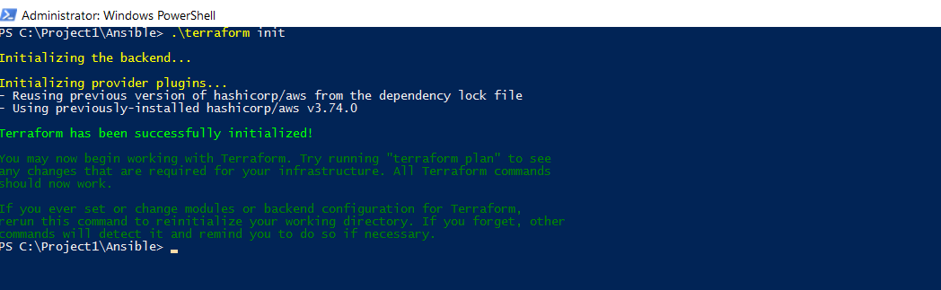

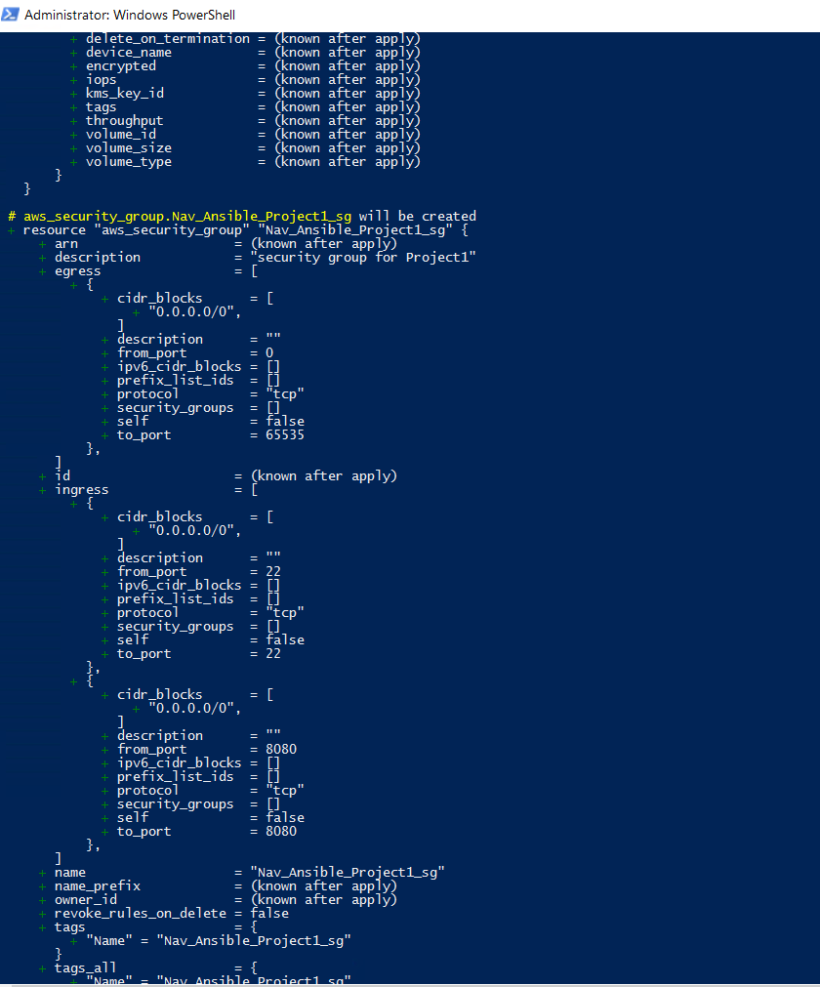

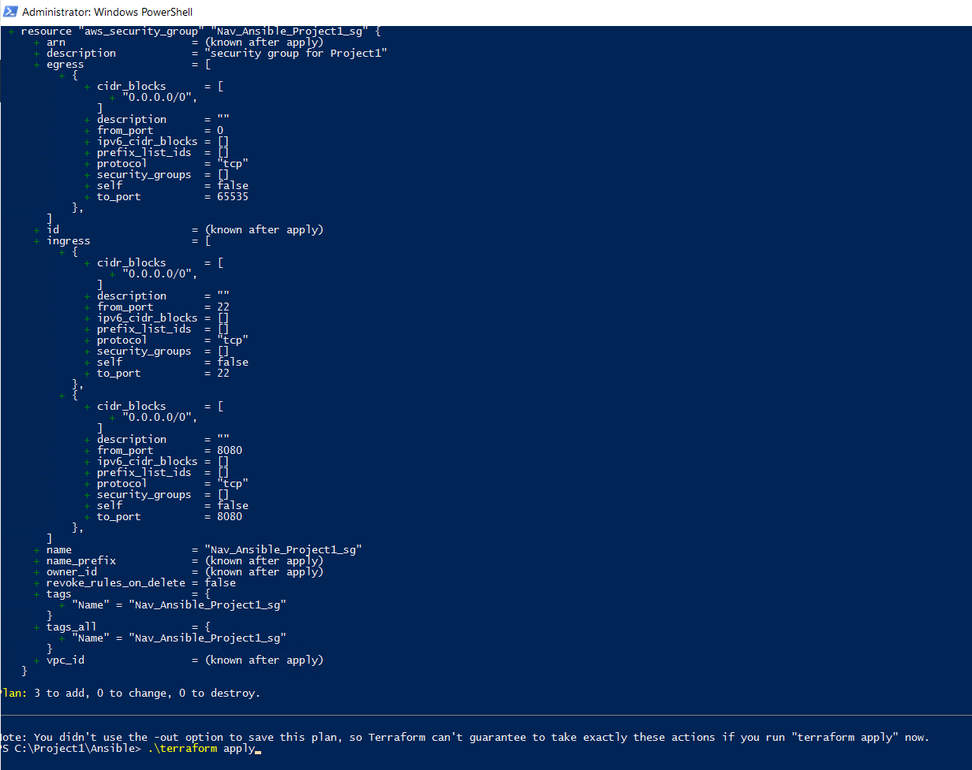

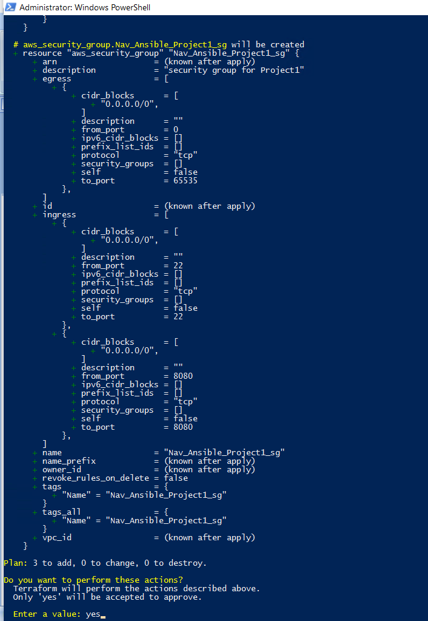

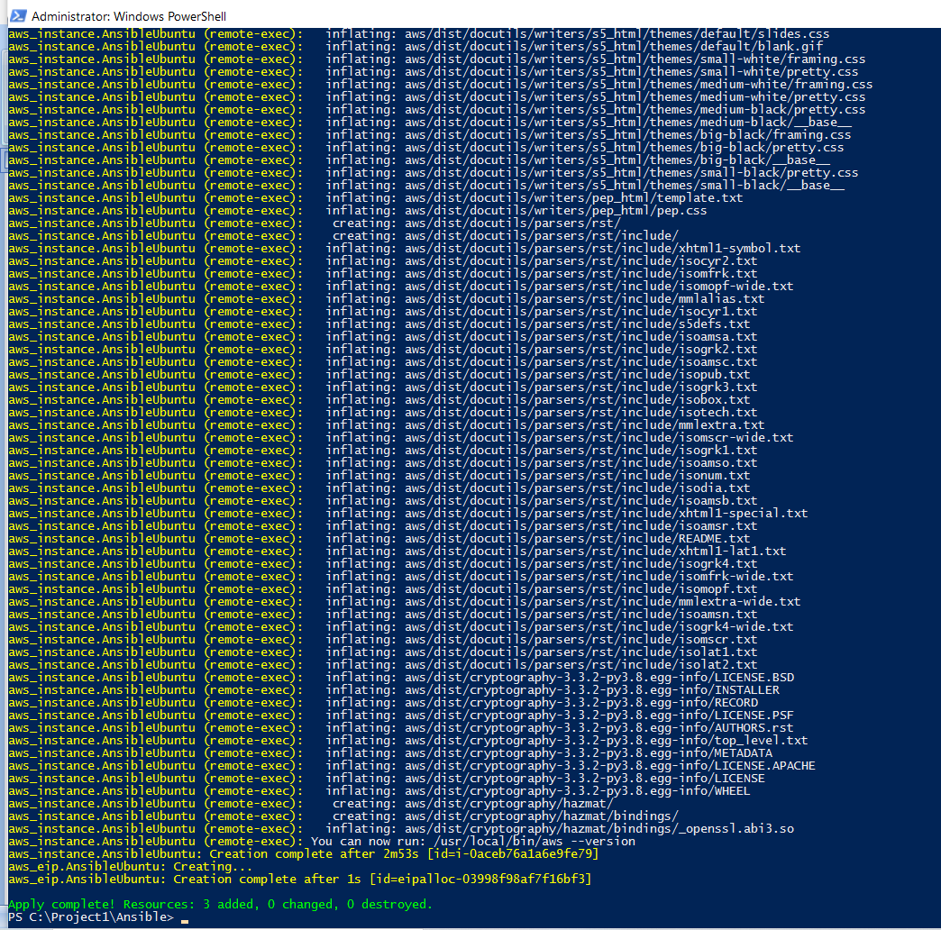

1. Execute Terraform init, Plan & apply for Jenkins Server Creation:

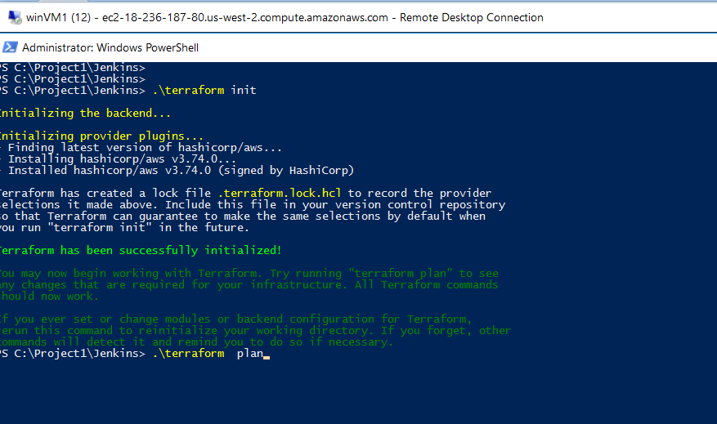

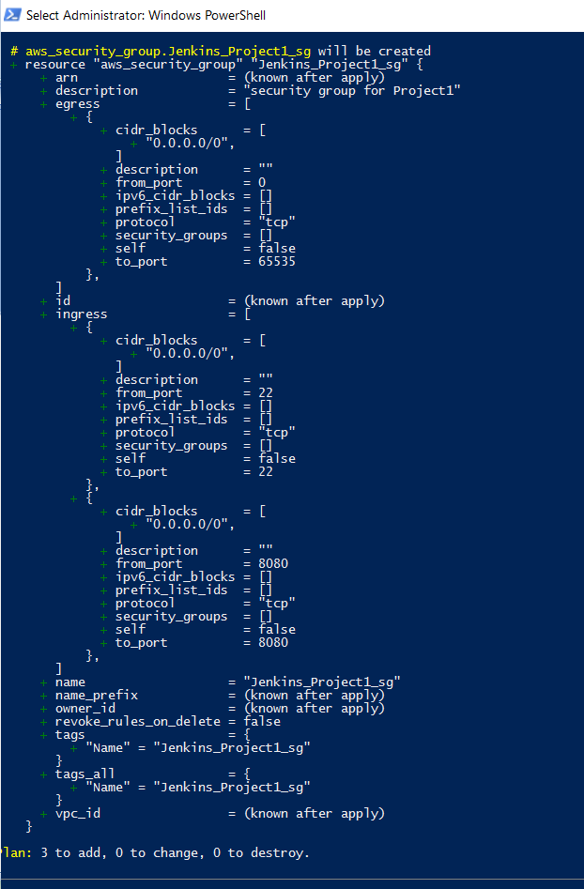

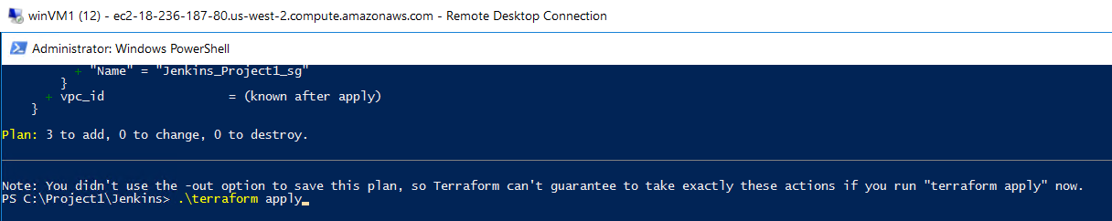

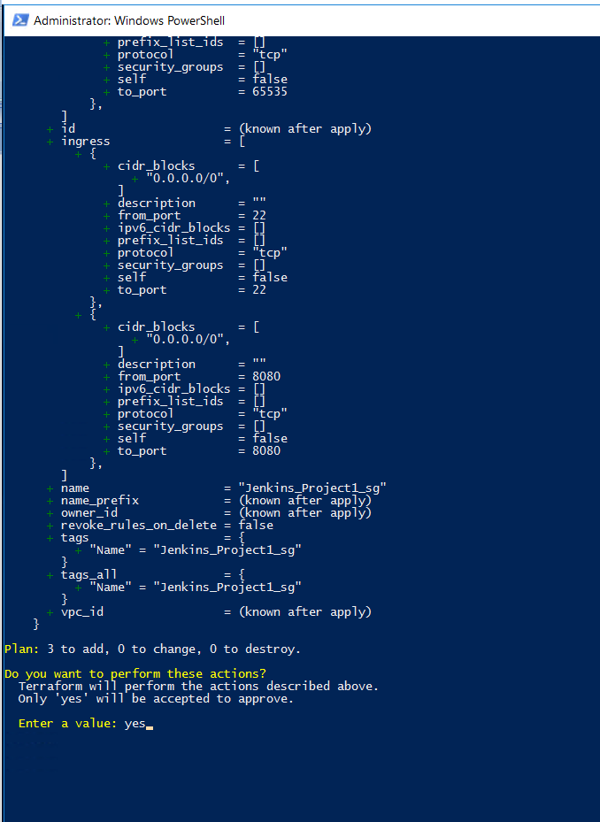

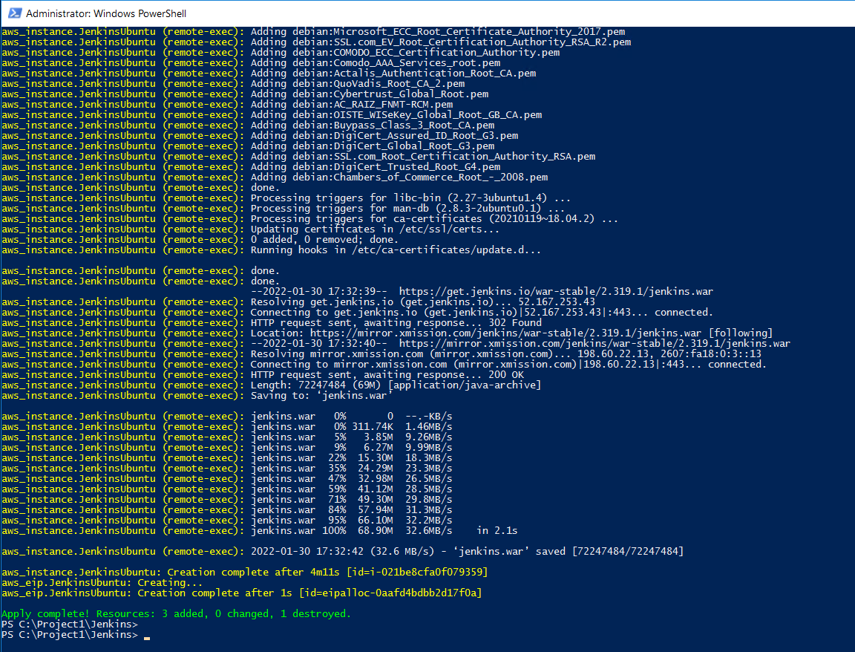

View in AWS Console for the 2 servers created:

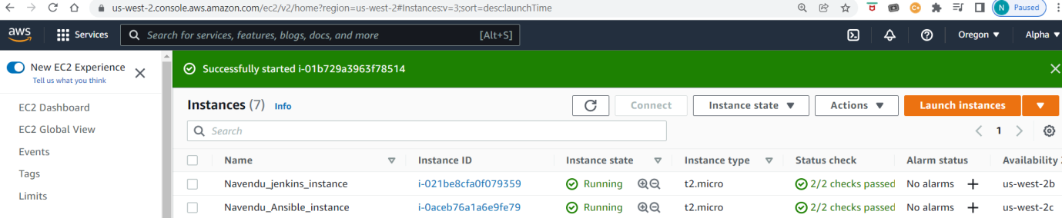

1. Login in to respective servers and verify if the required packages are installed
   1. Jenkins server - java and Jenkins

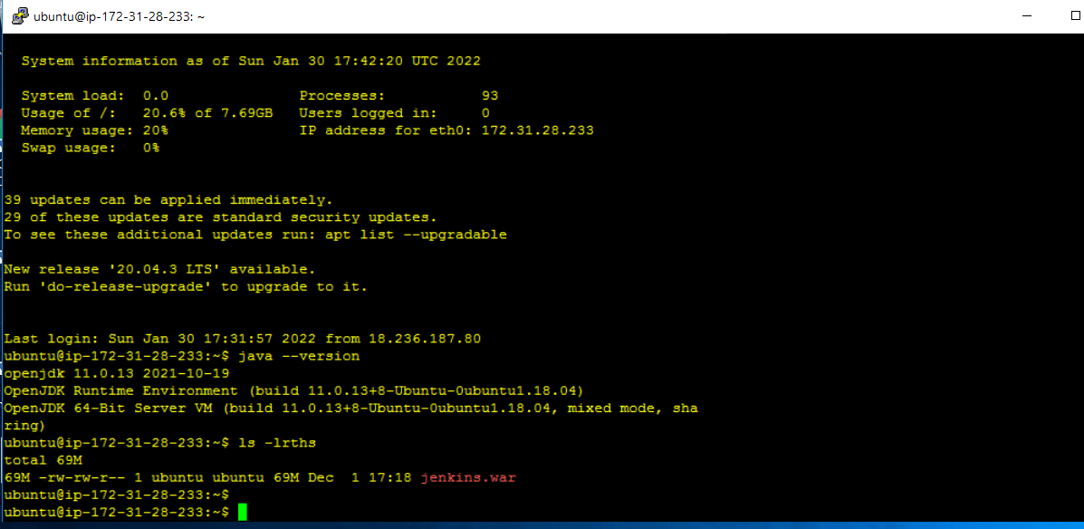

* 1. Ansible server: java, maven, ansible, docker, AWS CLI and GIT

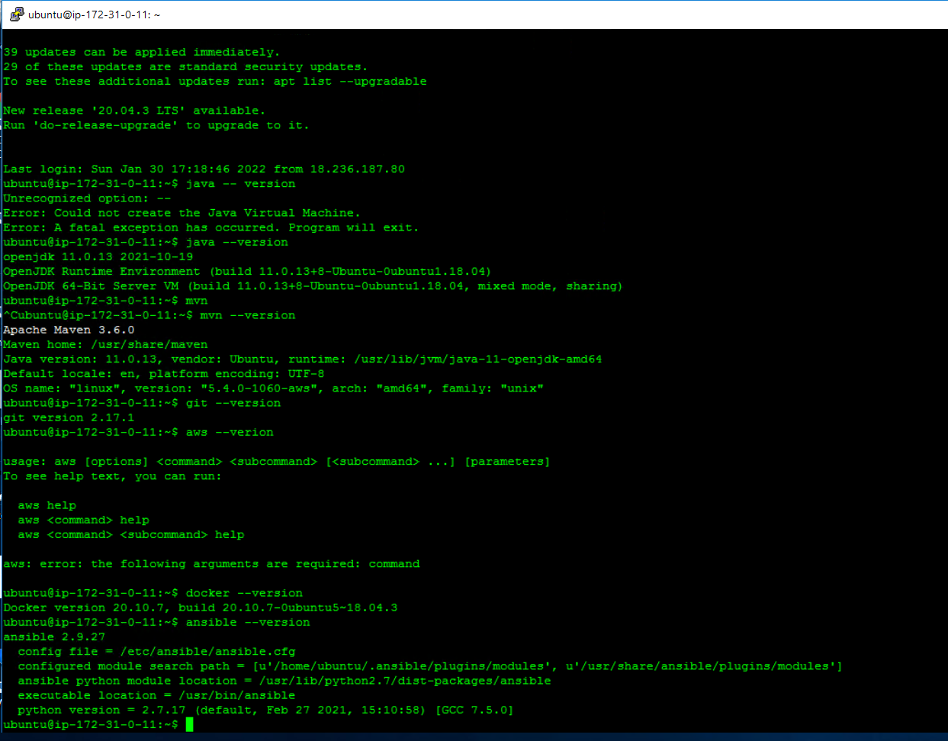

1. Keyless setup:
   1. Now run aws configure to setup aws console authentication on Ansible server

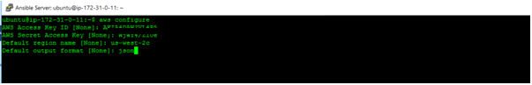

Generate public and private keys using ssh-keygen command on both servers

1. Ansible:

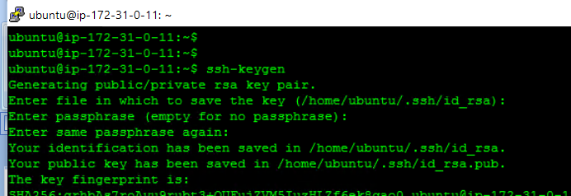

1. Jenkins:

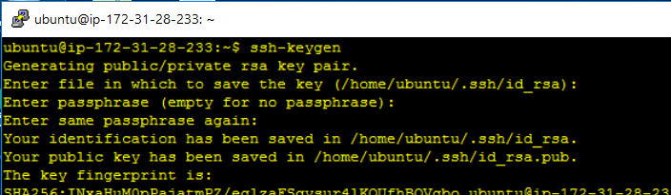

1. Add the following line in /etc/sudoers file on both servers (Jenkins and Ansible) using the root credentials:

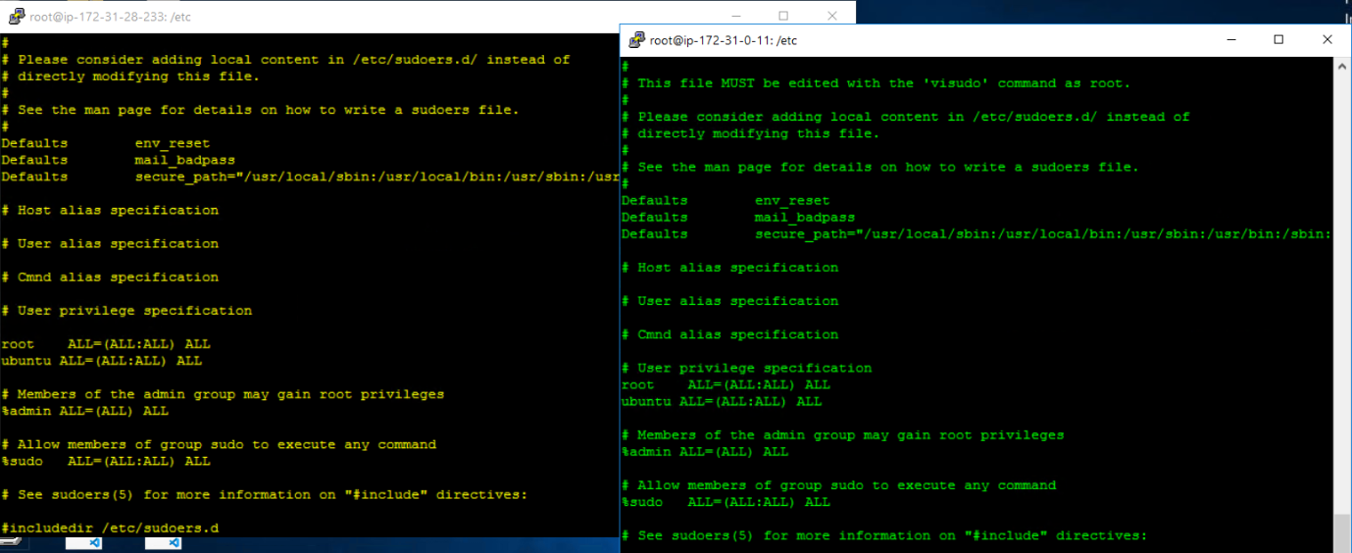

1. Now on Ansible node server create “Jenkins” folder and provide rights (chmod 777)

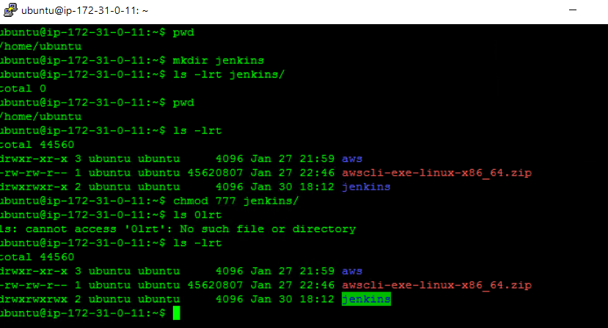

1. Public key of both Ansible server & Jenkinss server to be added to the file “/home/ubuntu/.ssh/authorized_keys” on Ansible server.

(Screenshot with “keys” missed out on purpose)

1. Start Jenkins on Jenkins server :

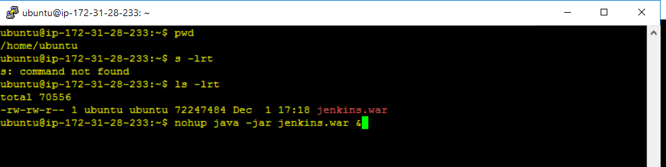

1. Get the admin password for initial set up from home/ubuntu/.jenkins/secrets/ initialAdminPassword and unlock Jenkins and create a user.

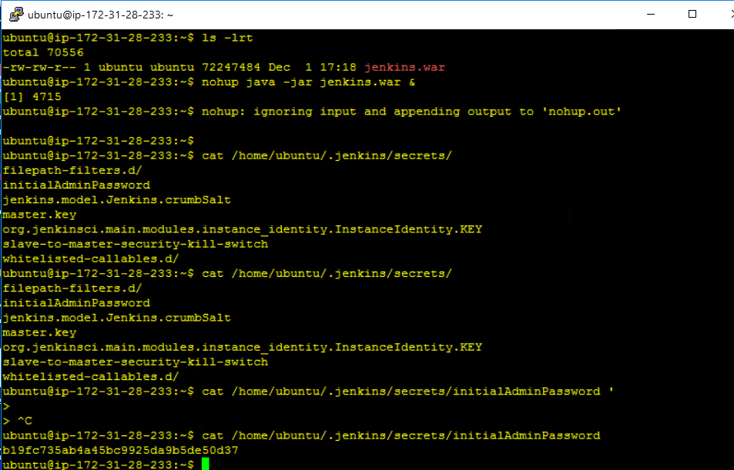

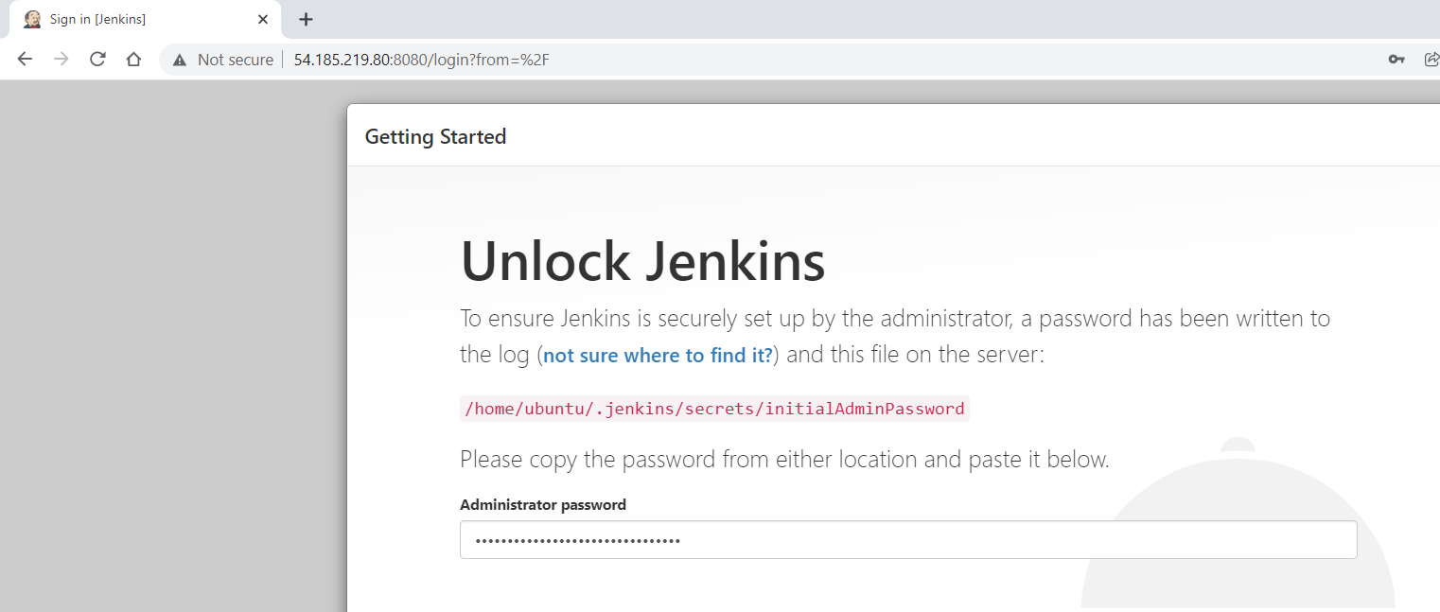

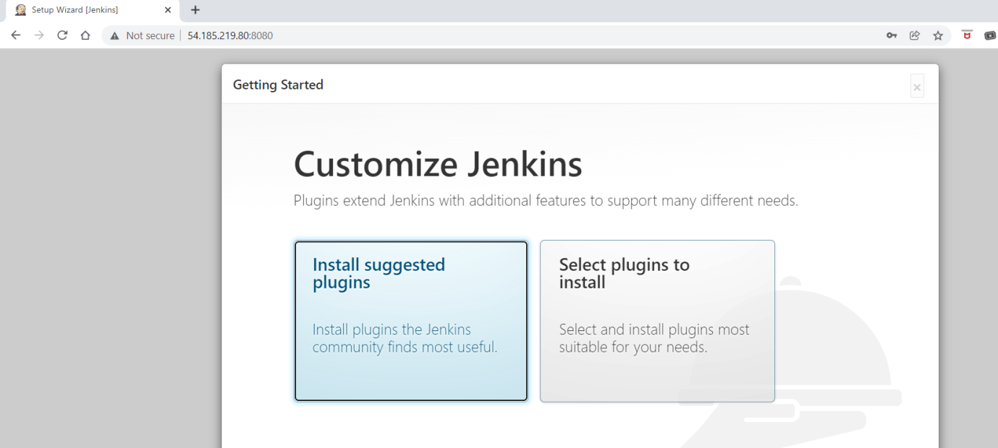

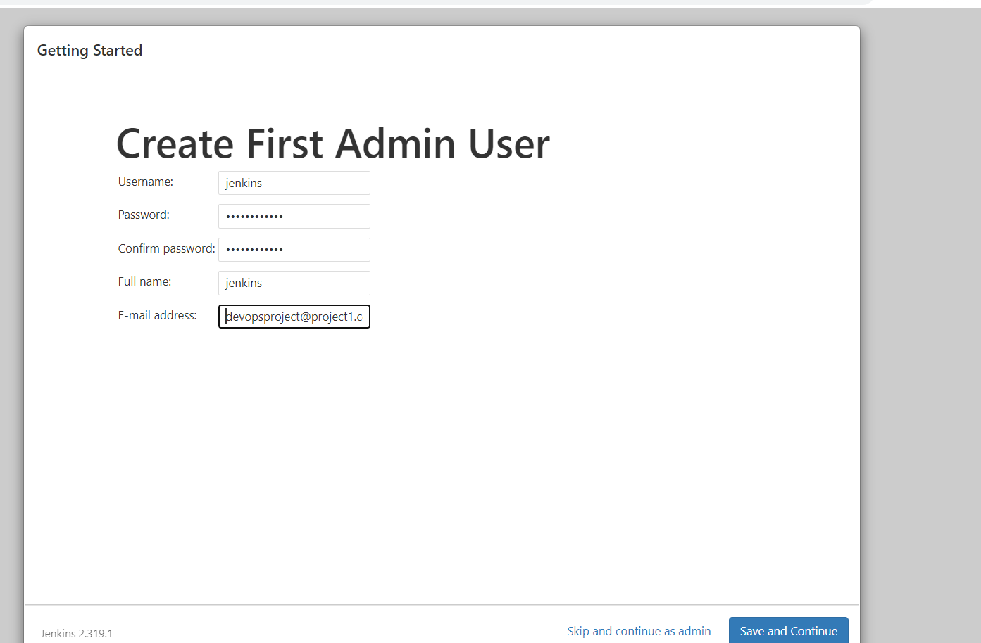

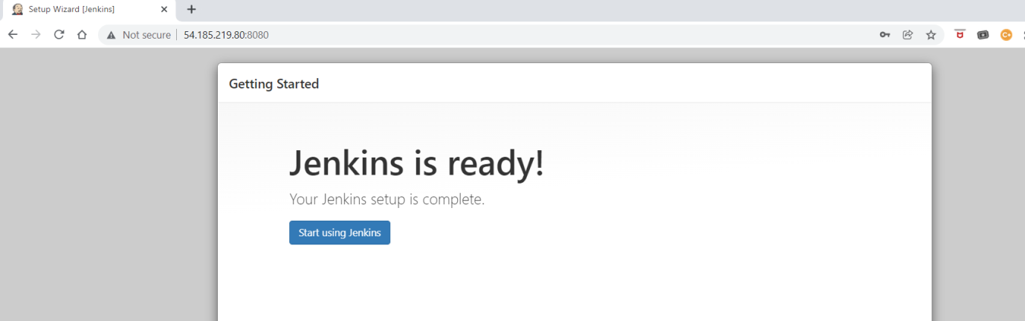

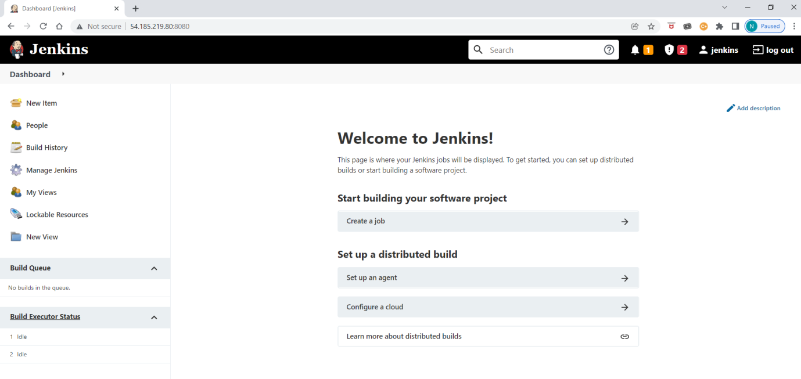

Go to Manage Jenkins -> Manage nodes and clouds -> New node

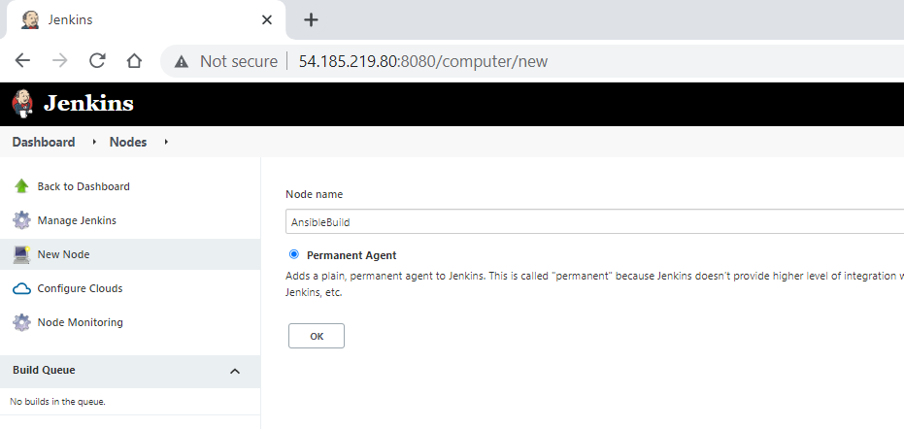

Select name (I used: AnsibleBuild) and enable permanent.

Update Remote root directory, Labels. Select Launch method as “Launch agent via SSH”.

Update private ip of ansible node as host.

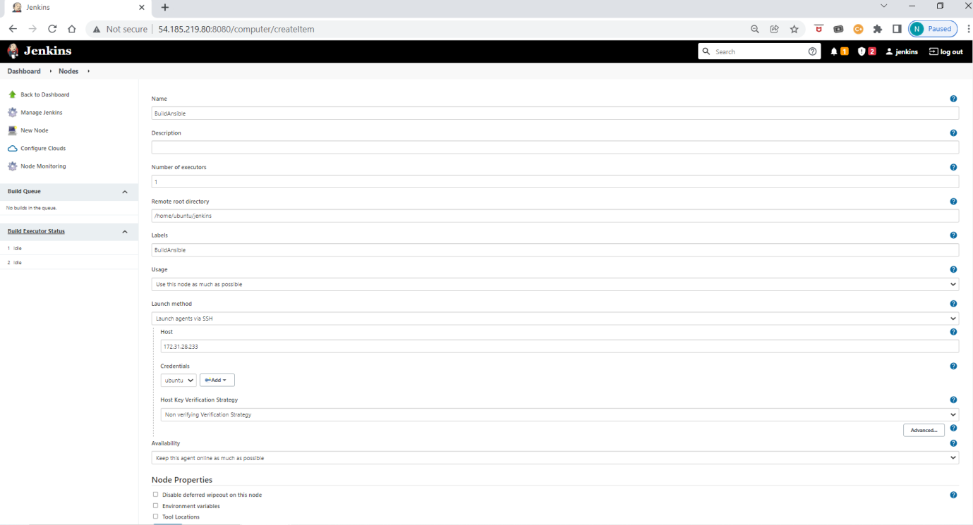

Add credentials “ SSH username with private key” and username: ubuntu and enter private key of ubuntu user in Ansible node instance

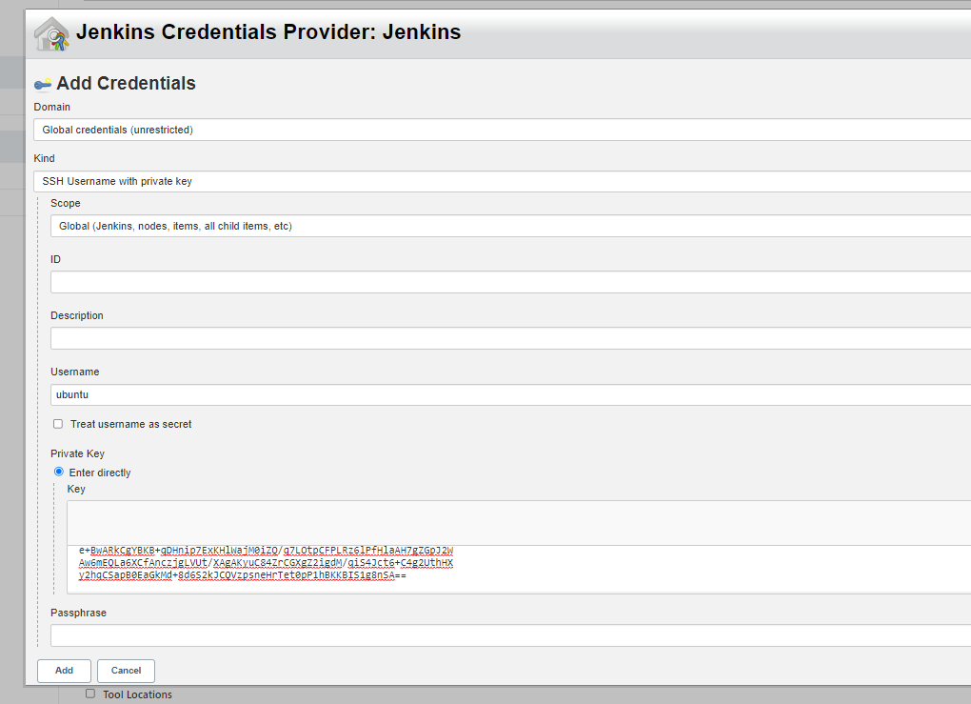

Once completed the node can be seen in the list :

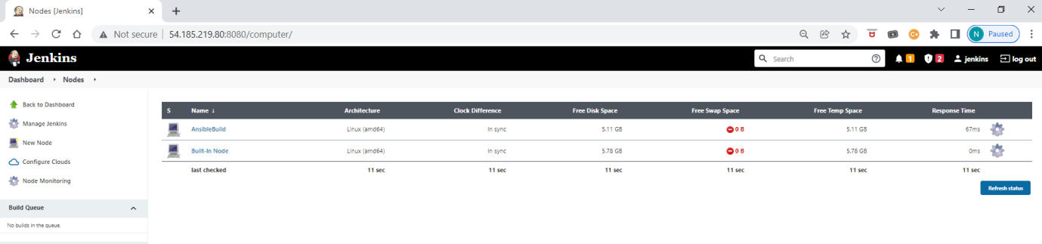

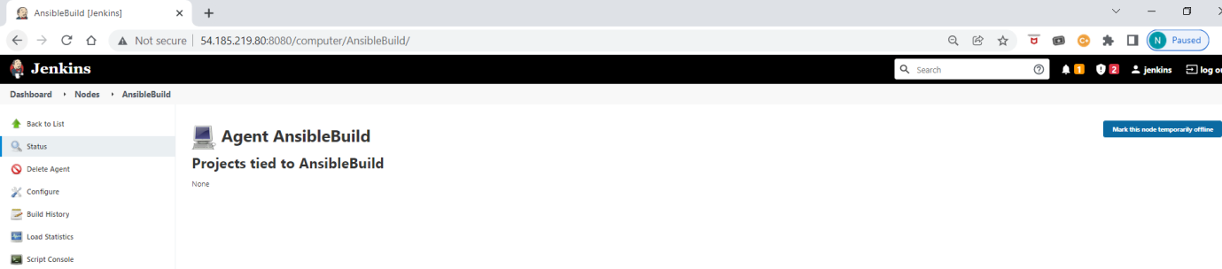

Make sure that build in node usage is changed to below.

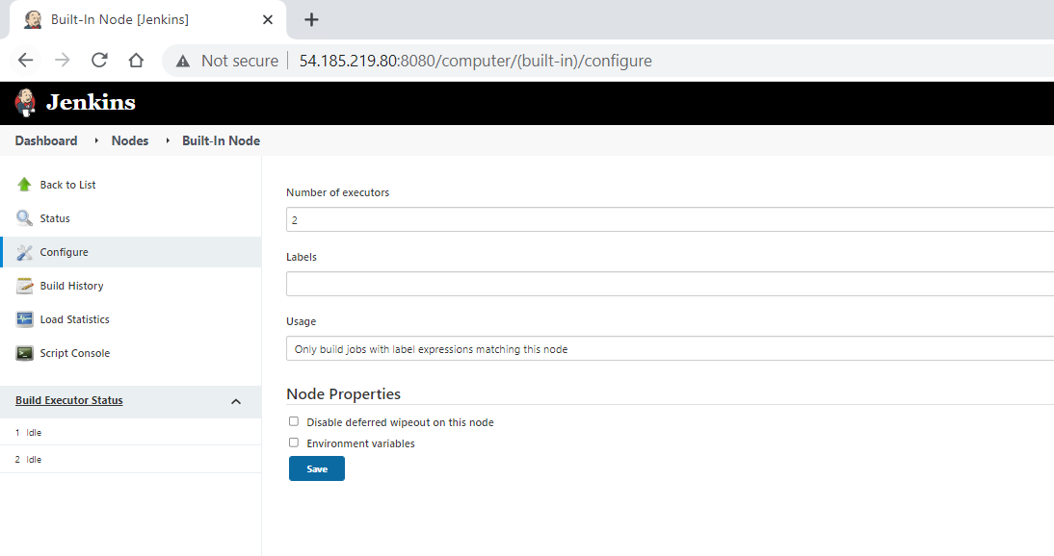

Install the following plugins from Dashboard > Manage Jenkins > Manage Plugins

* Git Hub Integration
* Maven Integration
* Docker
* CloudBees Docker Build and Publish
* Ansible
* Terraform
* AWS

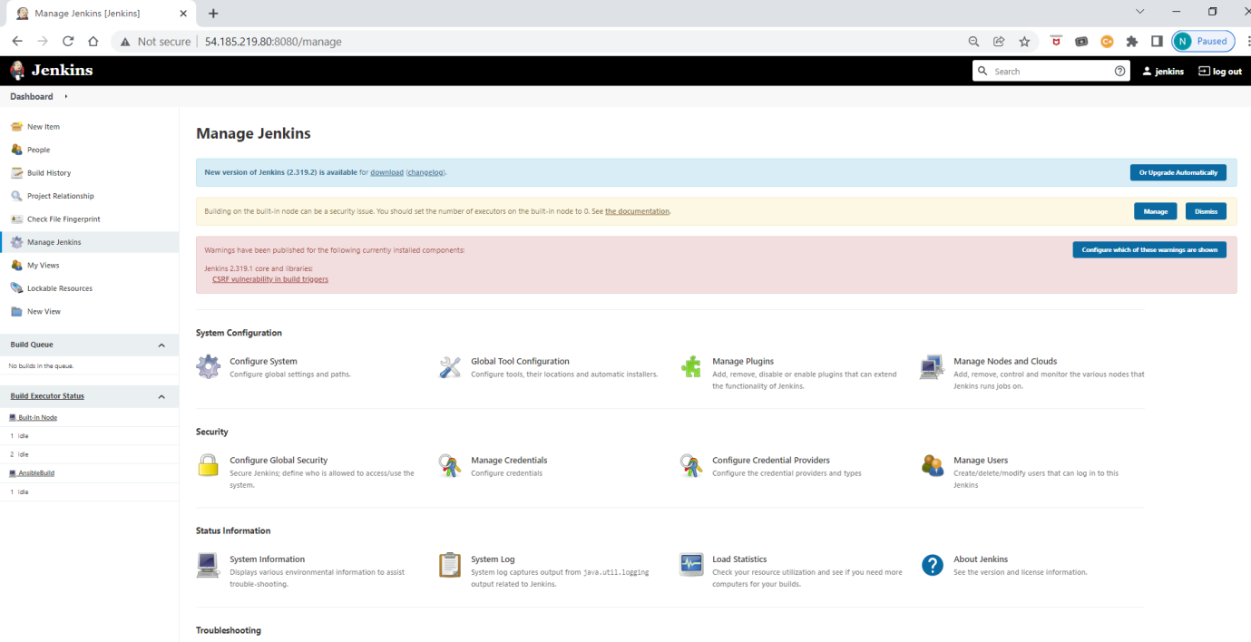

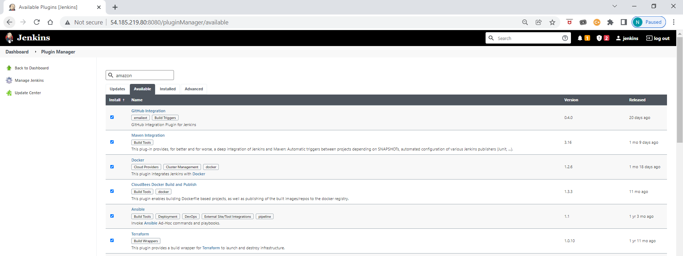

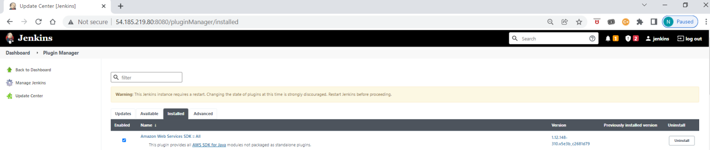

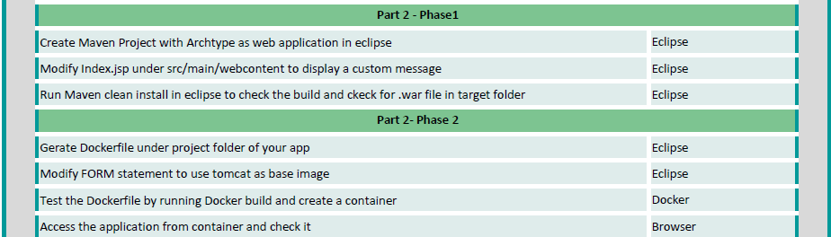

Creating a Maven project using Eclipse:

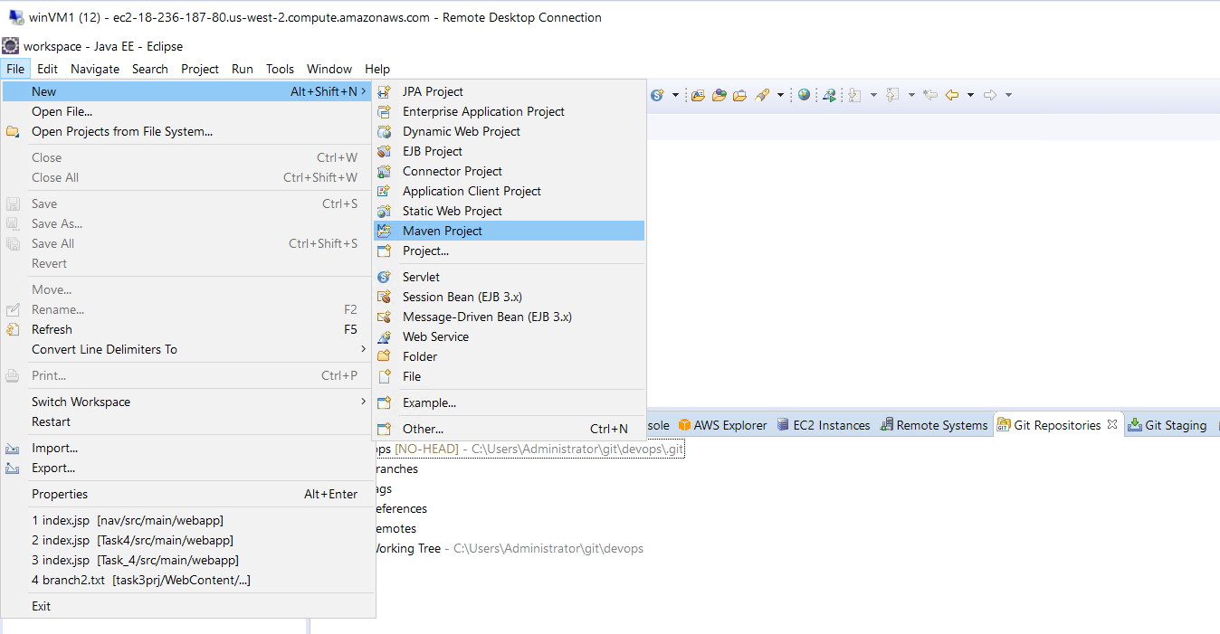

Maven-archtype-webapp project:

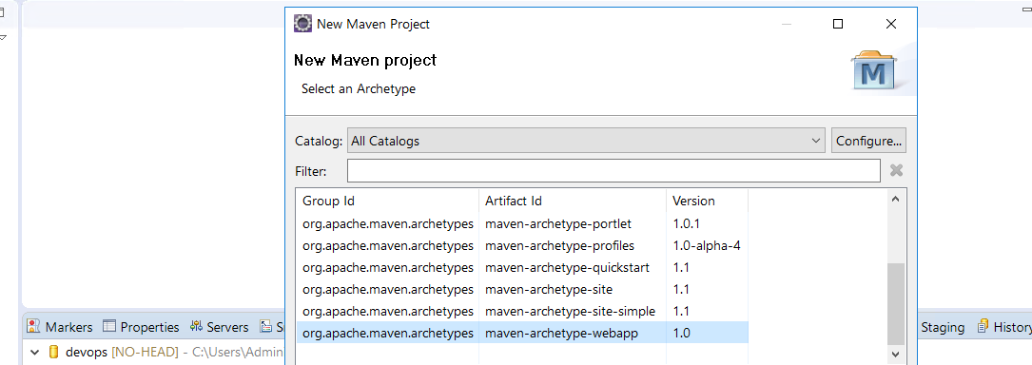

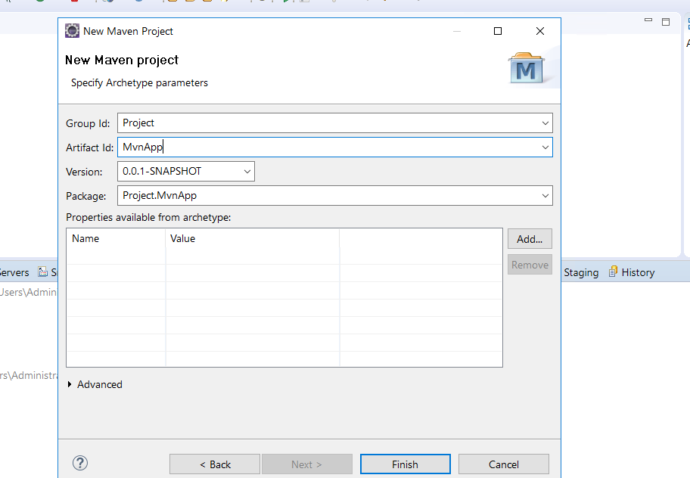

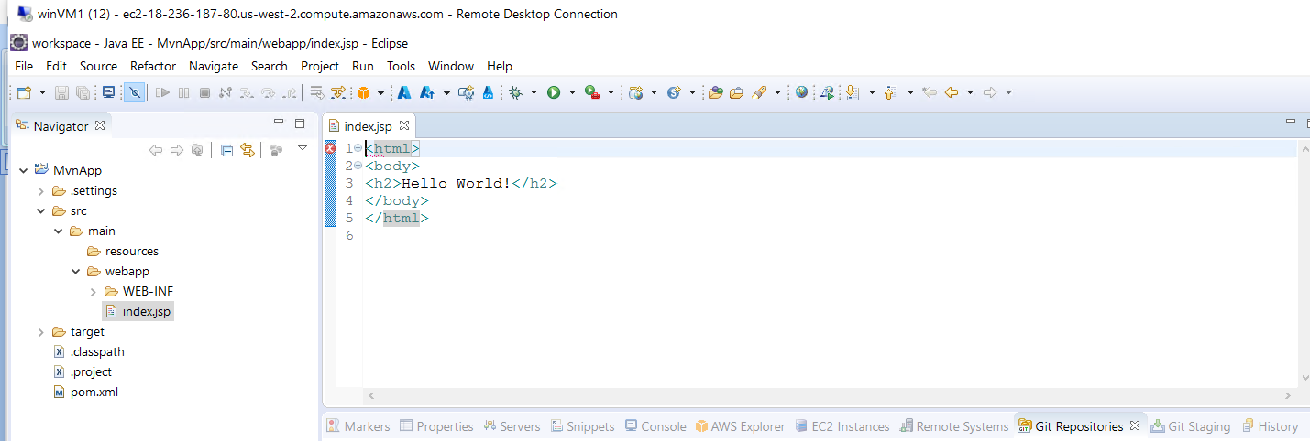

Make update to index.jsp and save the changes:

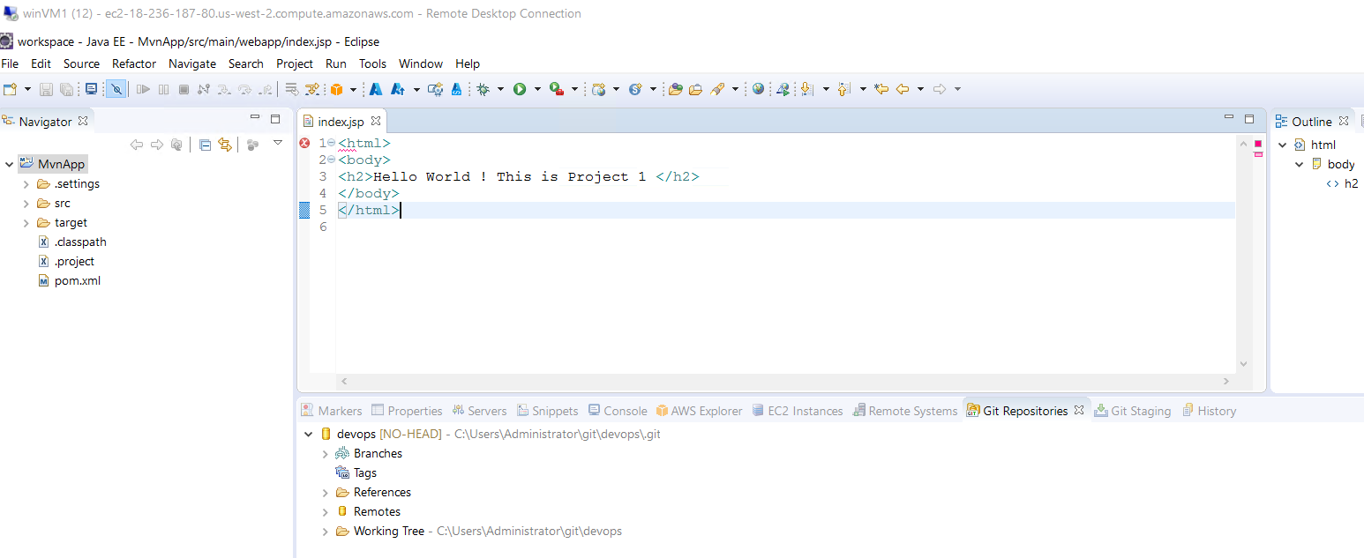

Create the Dockerfile and then to generate the .war file - ‘Run as’ from the menu -> ‘Maven install’ and it will generate MvnApp.war in “target” folder:

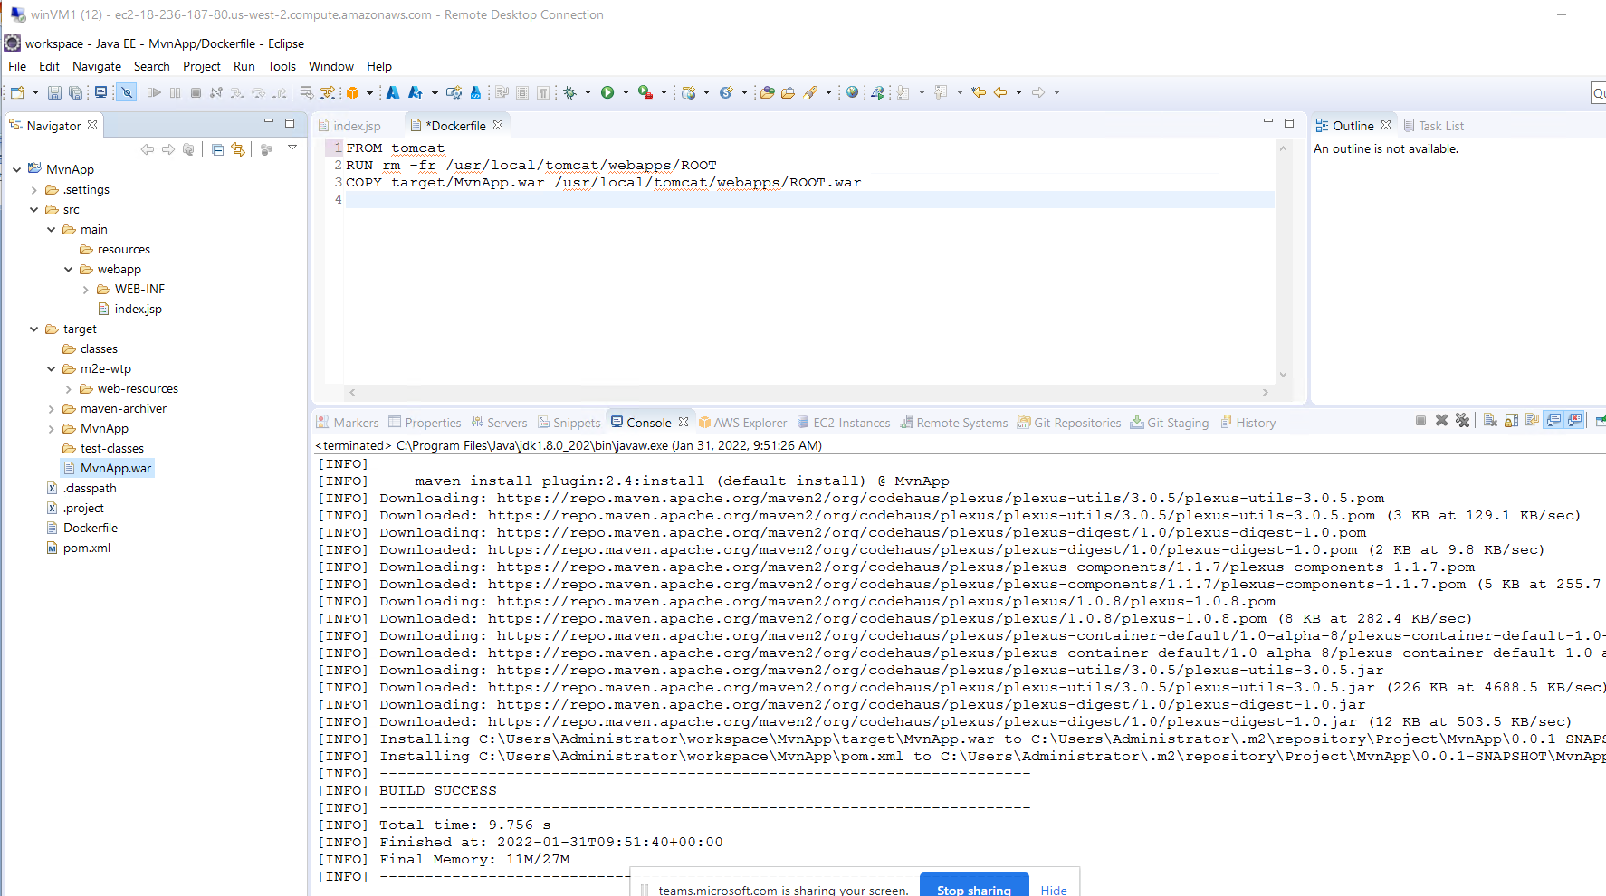

To test the Dockerfile: Compress MvnApp project folder

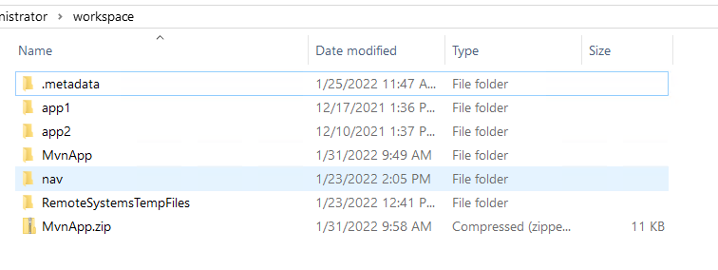

Copy the project zip file using winscp to Ansible instance and unzip it.

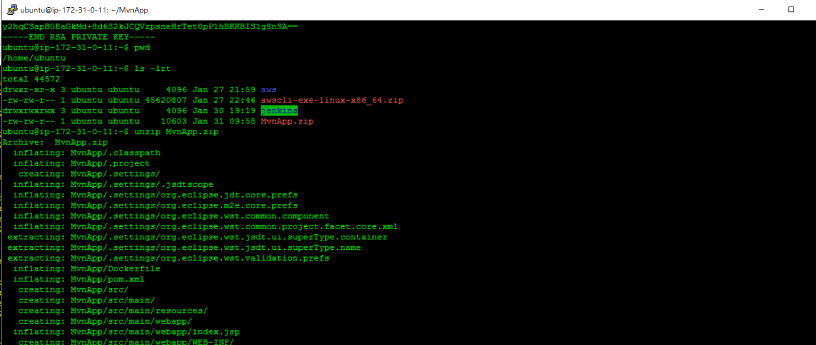

Open MvnApp folder to see docker and project files and execute: “sudo docker build -t mvnapp1 . “ to build docker image

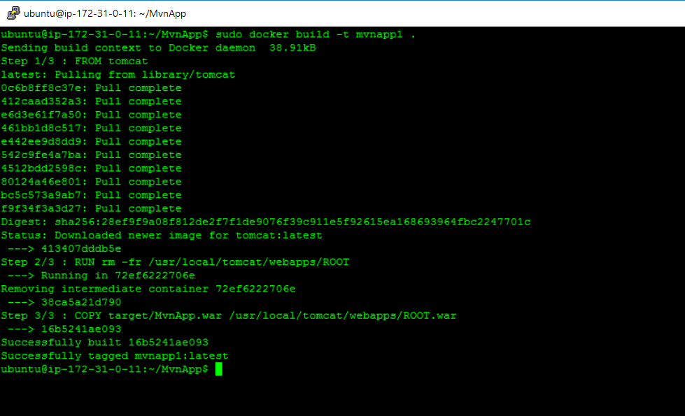

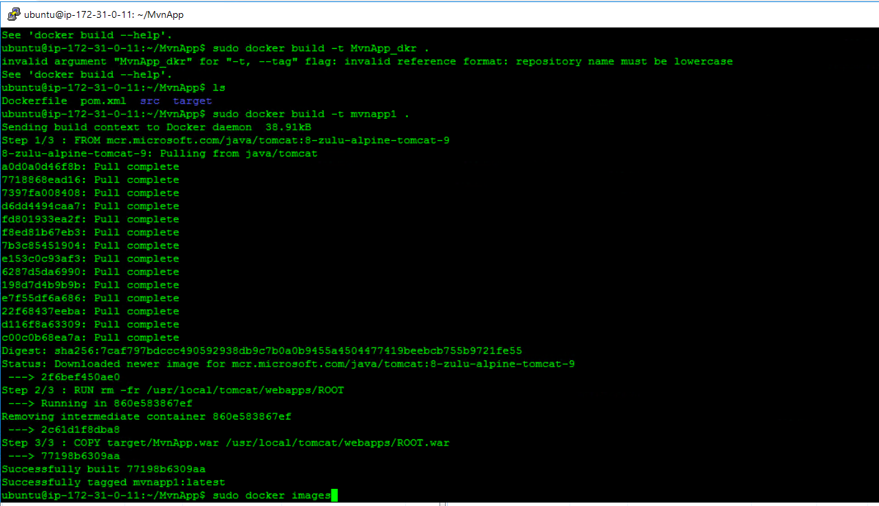

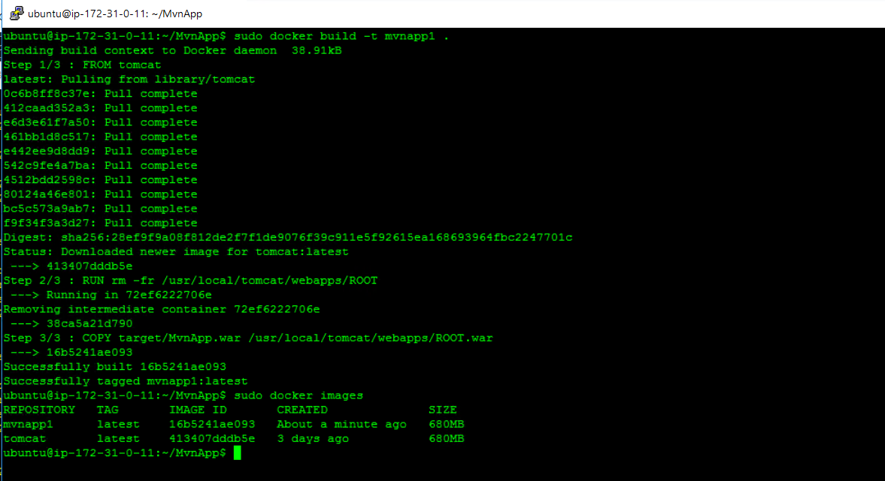

Create a docker container from ‘mvnapp1’ and check if it’s running.

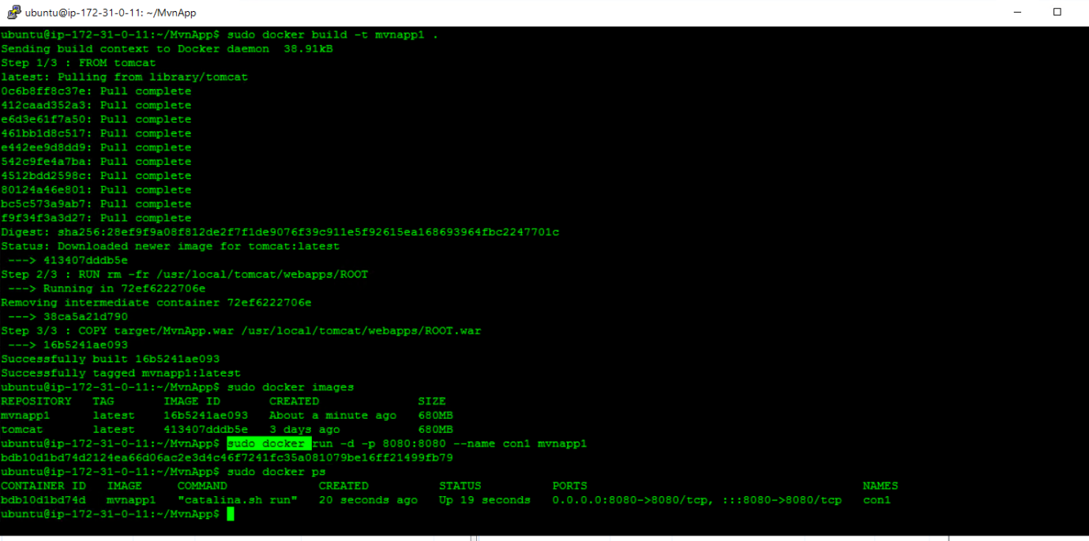

Using Server public IP address with port 8080 to check the page:

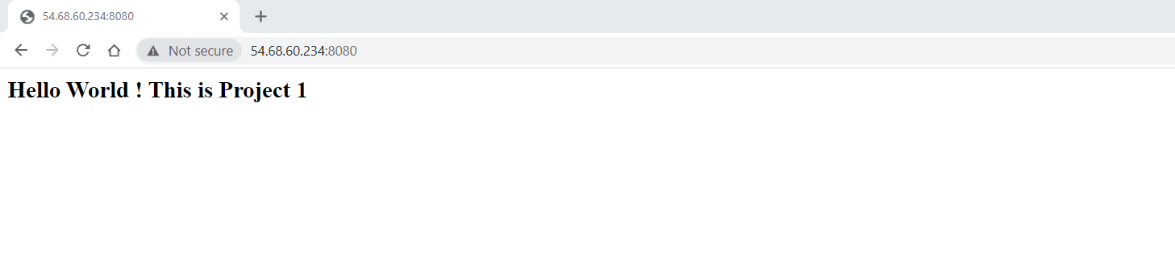

Once the test is successful, remove the container and image:

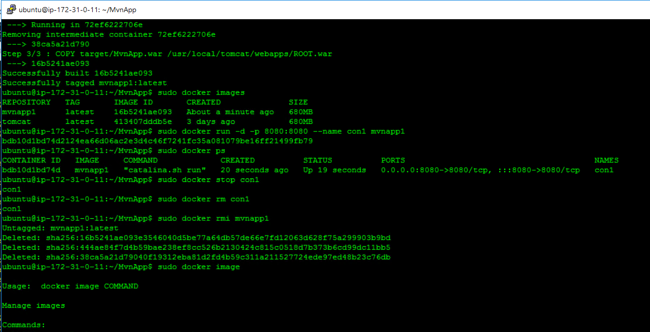

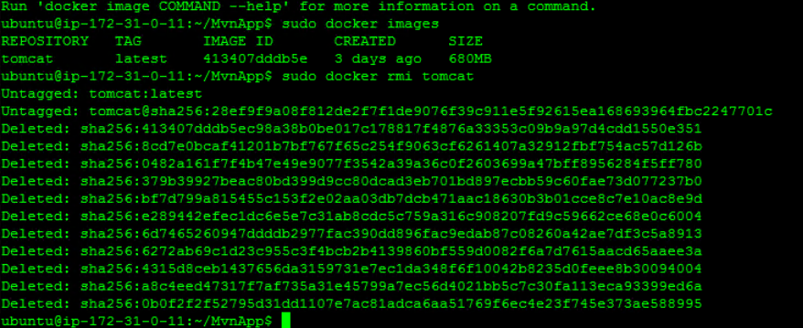

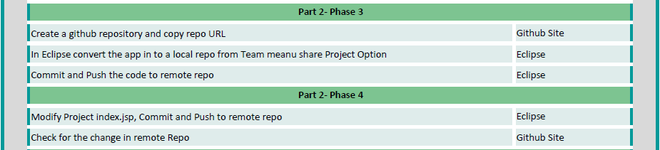

Created a Git repository:

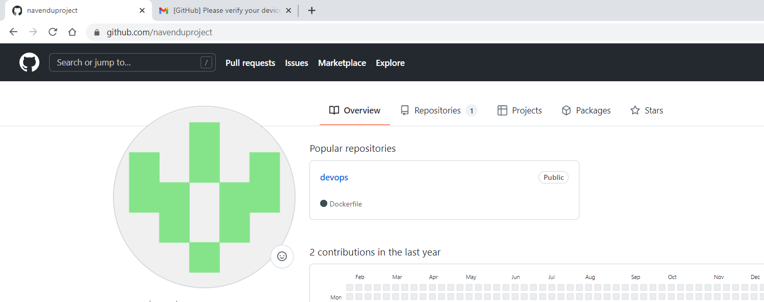

Connect Git repository from Eclipse and commit/push the project, verify the same in git hub repository :

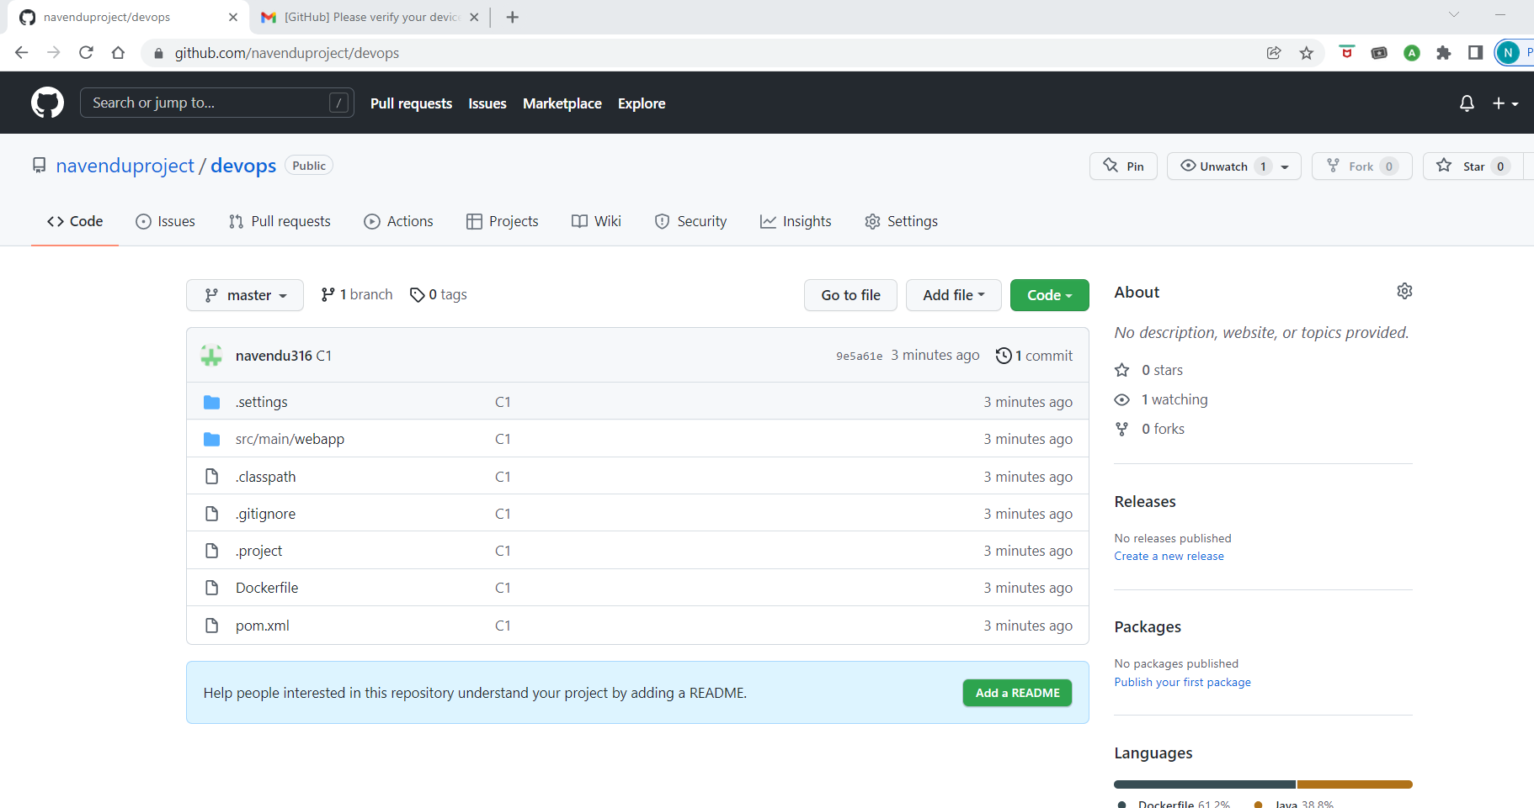

Make change and push:

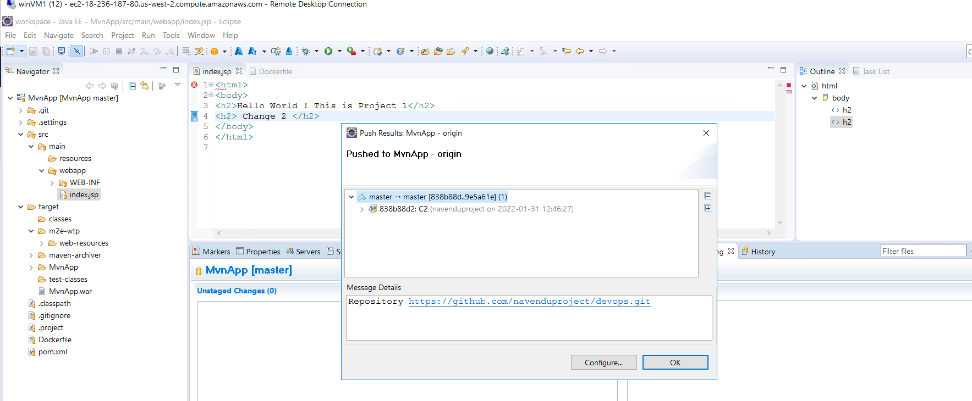

Changes reflected in Git repo:

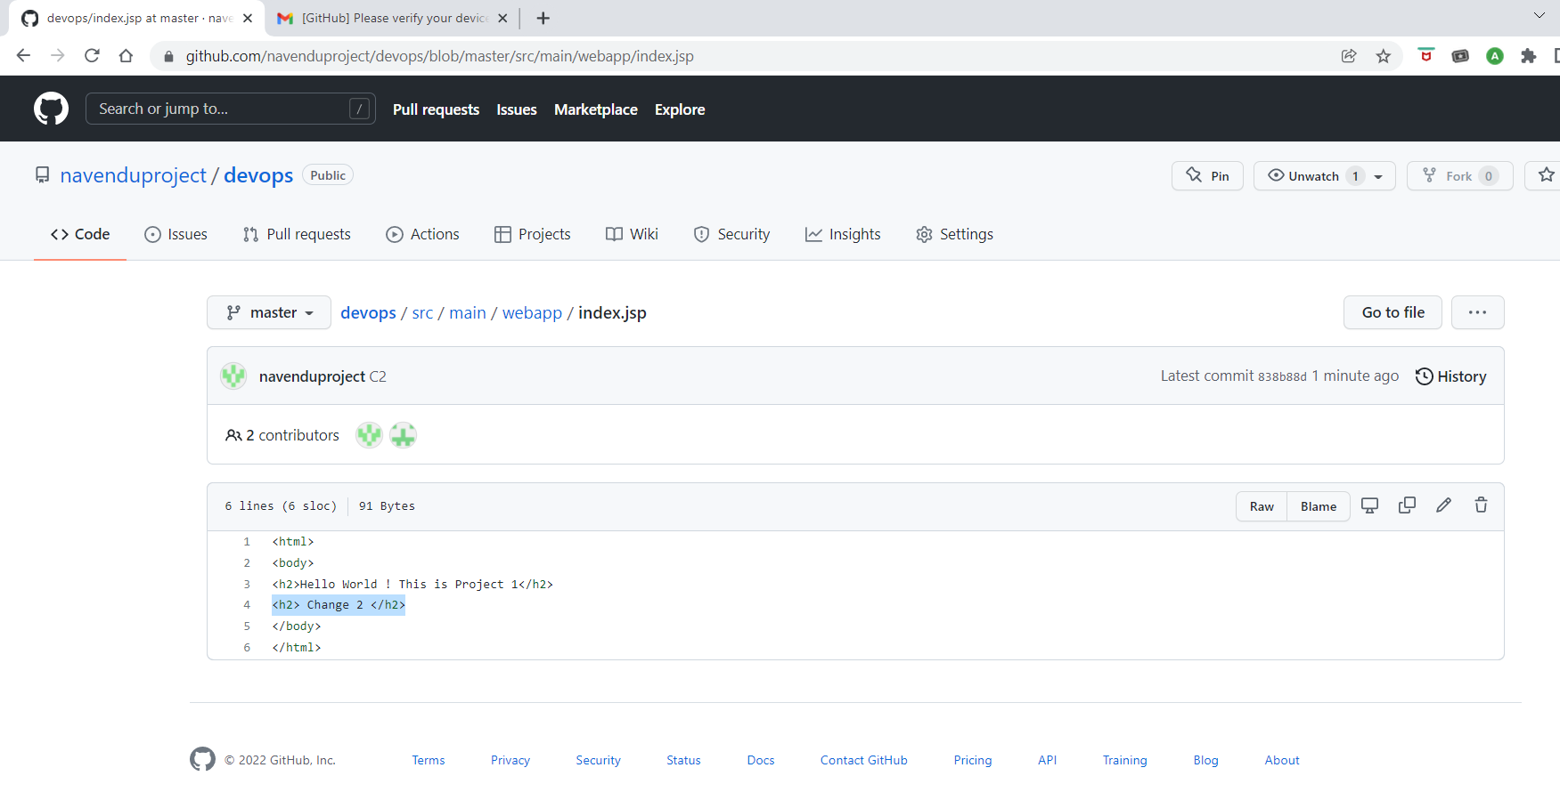

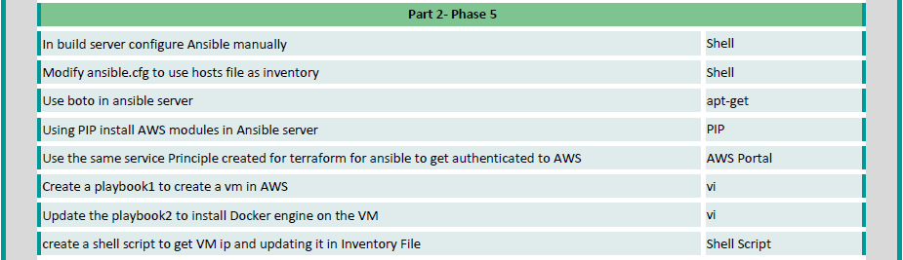

Verify Ansible installation:

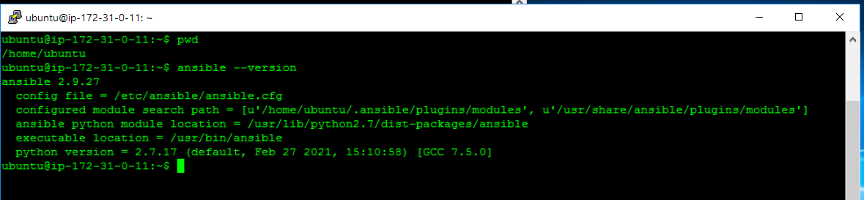

Change ownership of Ansible folder to user: ubuntu

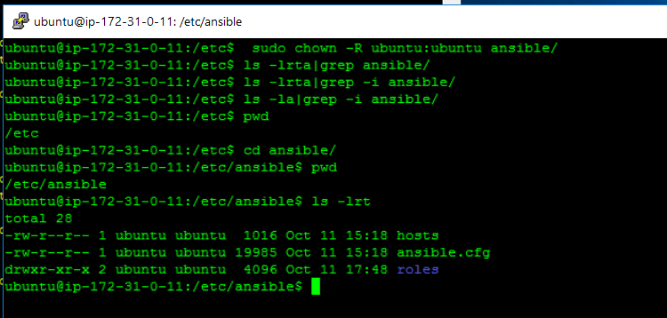

Confirm **.ansible** folder in home dir is under ubuntu ownership:

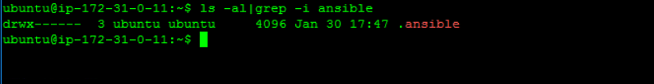

In /etc/ansible/ansible.cfg enable inventory and set deprecation_warnings as false

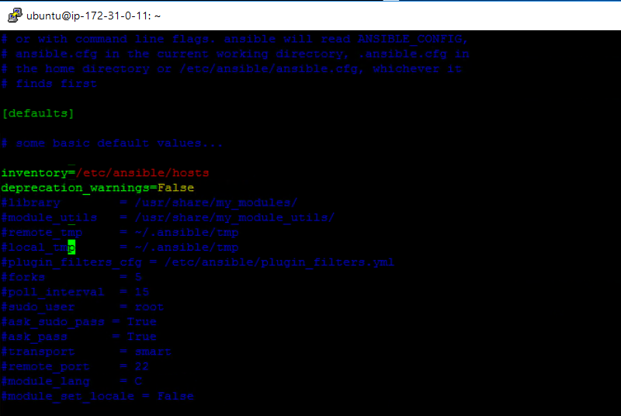

Now run the below commands

* sudo apt install python-pip
* pip install boto3

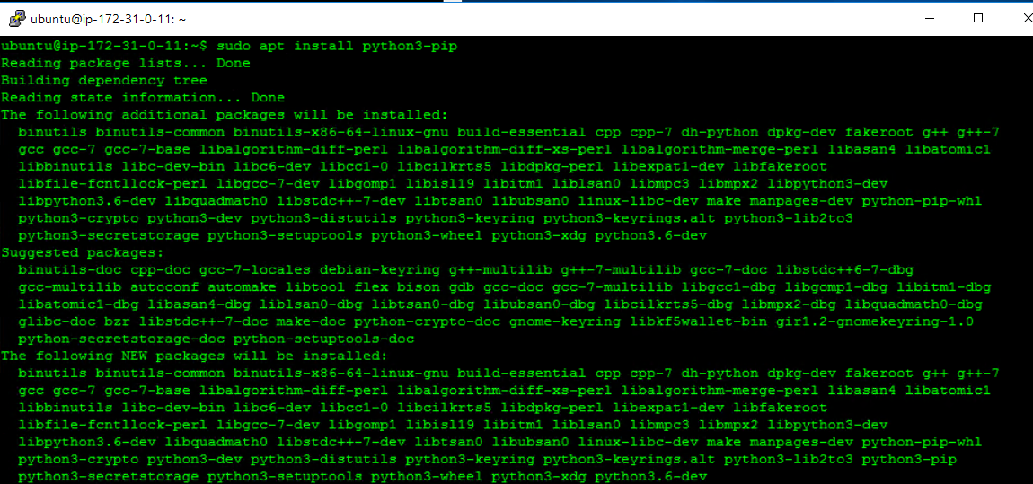

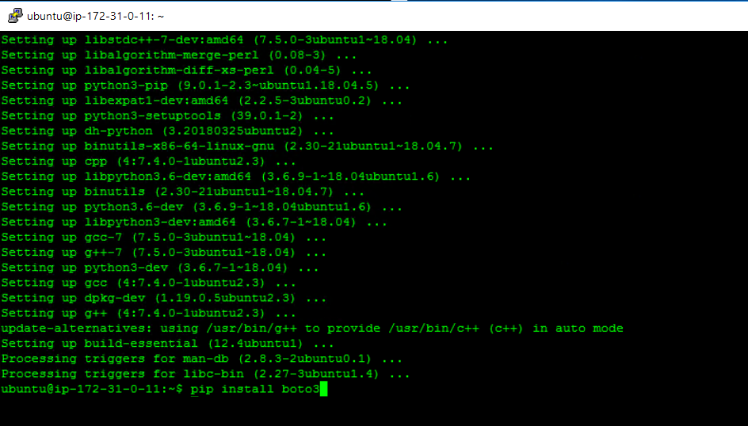

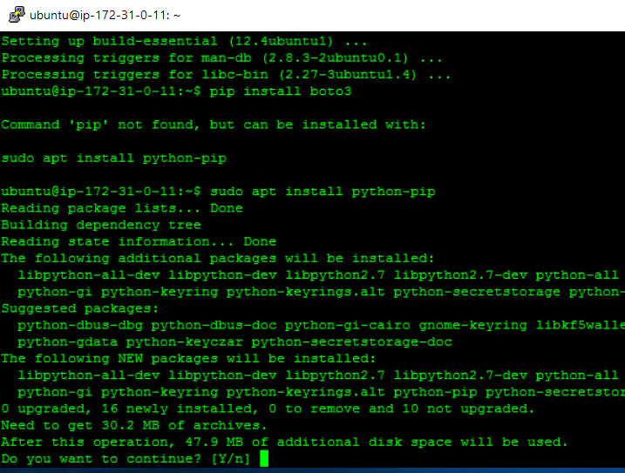

Open /etc/ansible/ansible.cfg file and add enable plugin line as shown below.

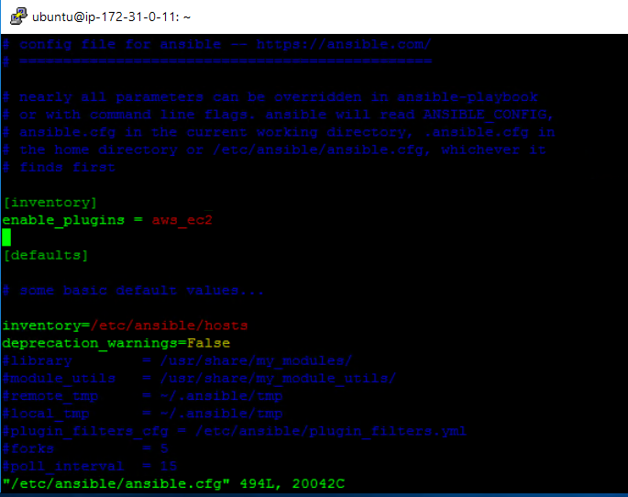

Create file aws_ec2.yml with AWS credentials and execute: “ansible --list-hosts -i aws_ec2.yml all”

Check list instances of EC2:

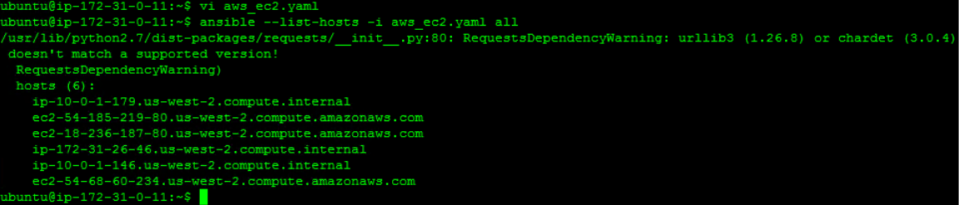

Copy the *.pem file to ansible server and give permissions as 600

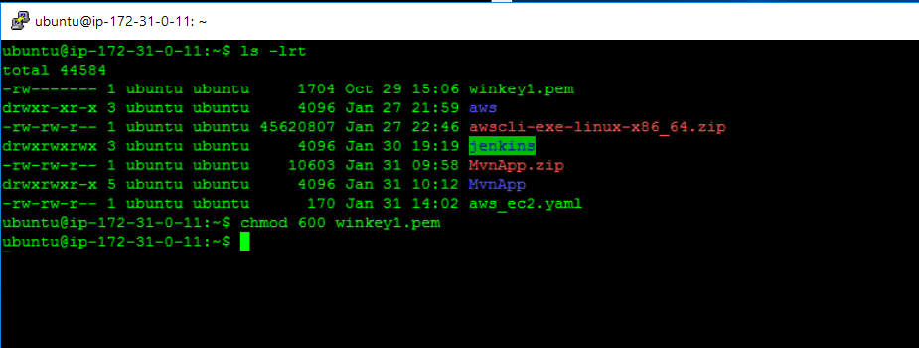

Create a playbook (playbook1.yml) which creates EC2 instance and adds it to private ip to hosts files



Now create ~/.ssh/config file with the below lines

Give permissions to file as 400 (sudo chmod 400 ~/.ssh/config)

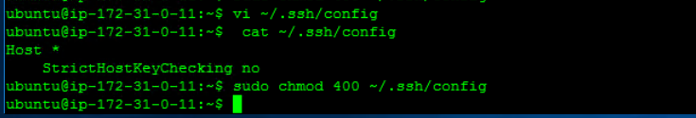

Create a another playbook (playbook2.yml) for installing docker in ec2 instance created from playbook1 :



(Playbook1.yml already has lines to copy private ip of newly created EC2 instance to inventory file)

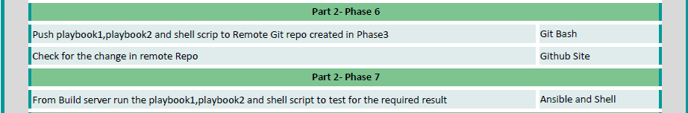

Uploaded both playbooks in github Project1 repository

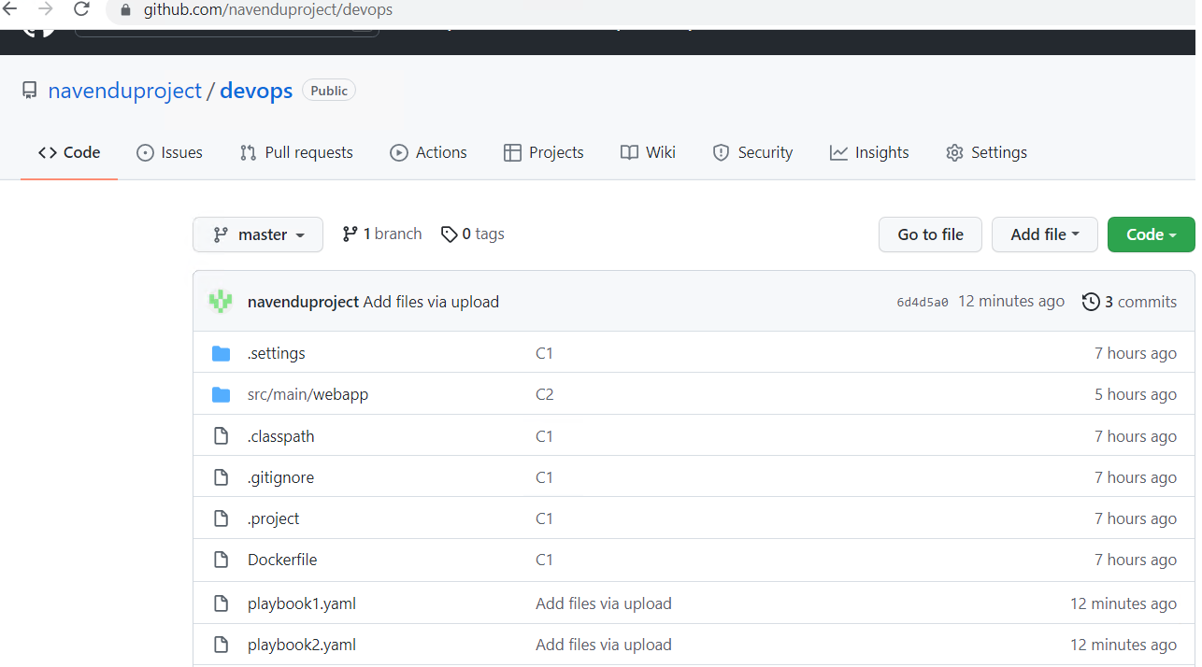

Create a playbook (playbook3.yml) to run on a new instance which stops & then removes existing container+image and then create the new container with latest image.



Create a shell script which will validate if Docker EC2 instance Project1 exists or not.

* If exists – then it will execute playbook3 which will use existing EC2 instanace to deploy latest docker image and container.
* If doesn’t exist – then it will start with playbook 1 followed by 2 to create new EC2 instance with name Project1 and then deploy the latest docker image



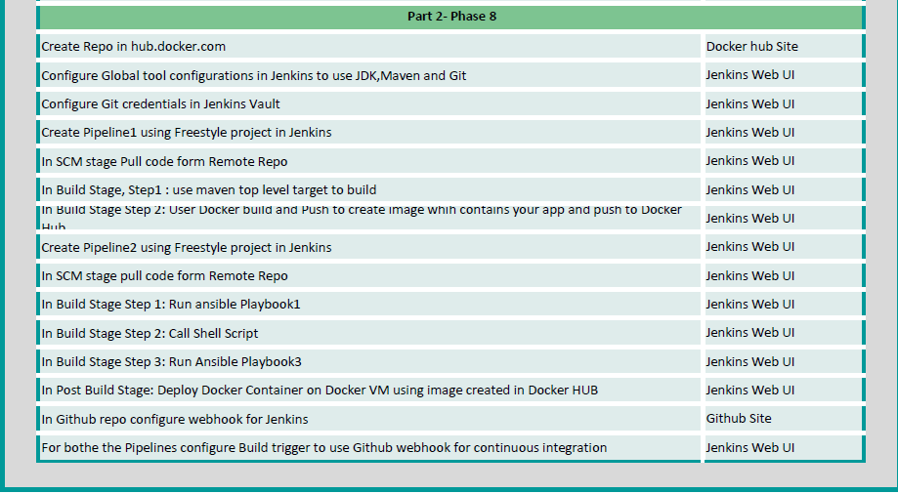

Create a new repo in Docker (project1)

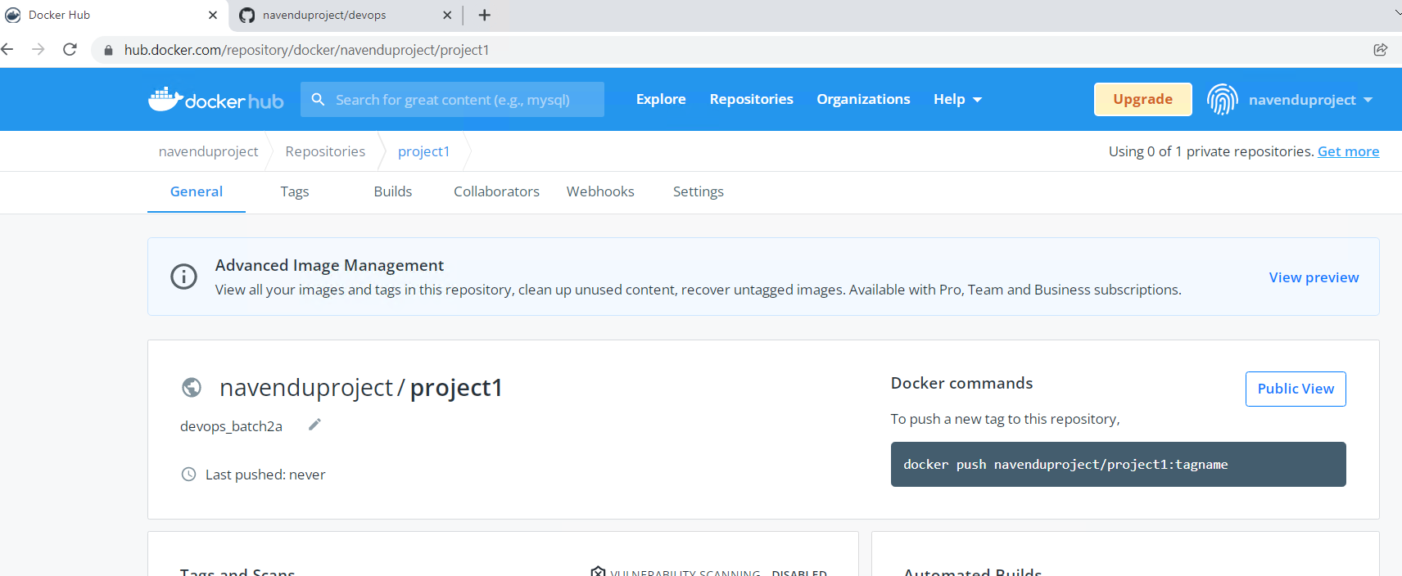

Pipeline creation:

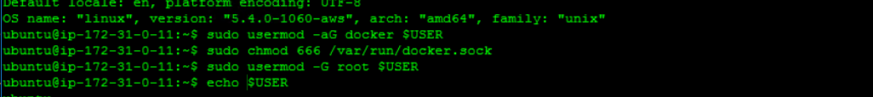

Creating a webhook:

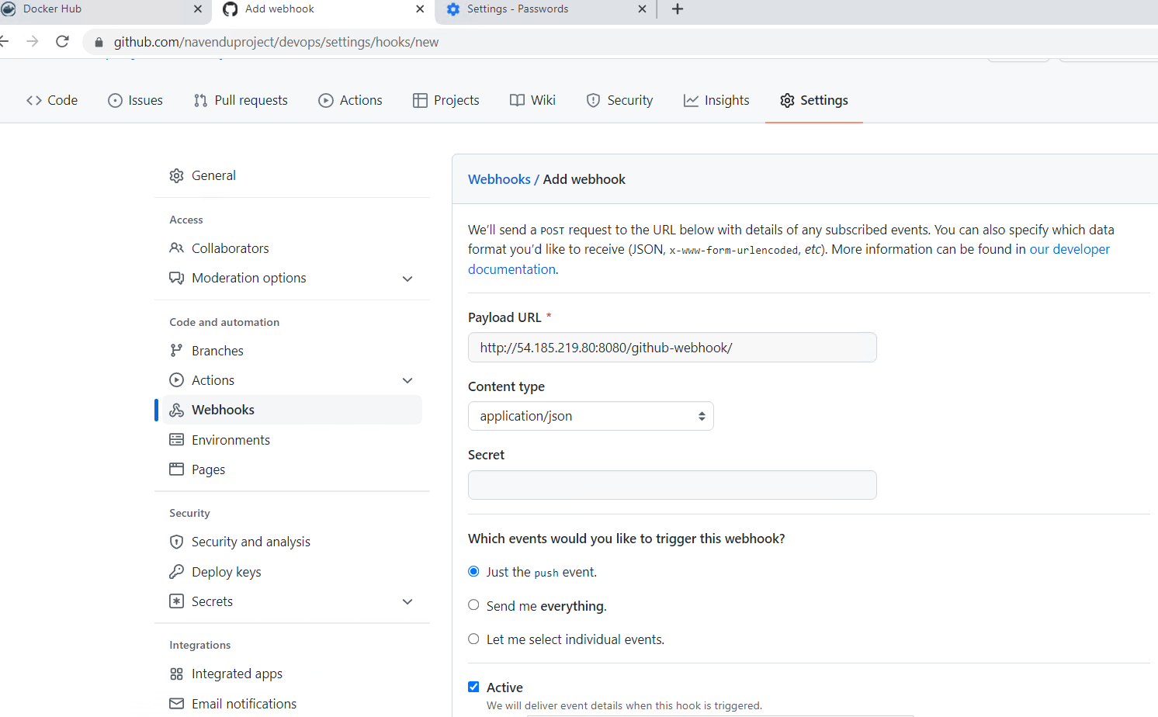

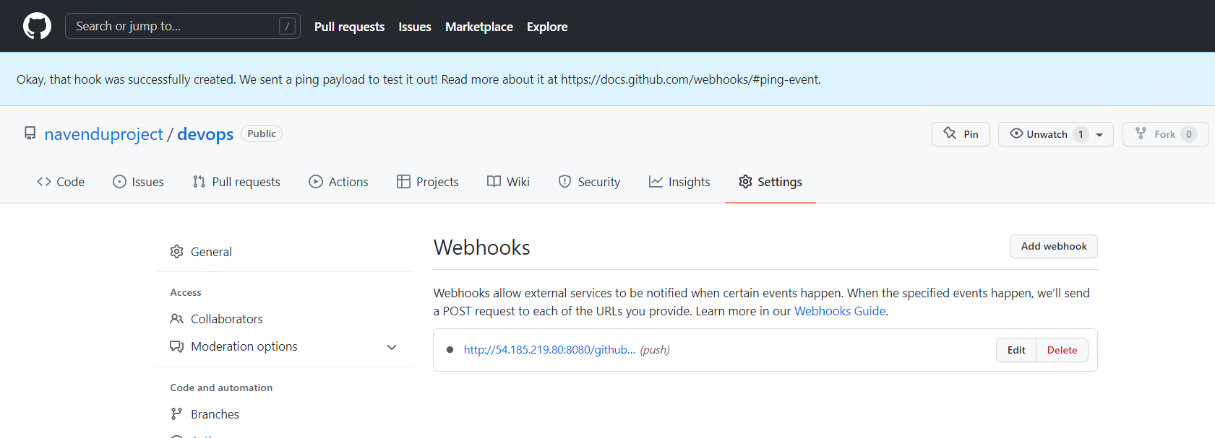

Jenkins : Global configuration – update

JDK:

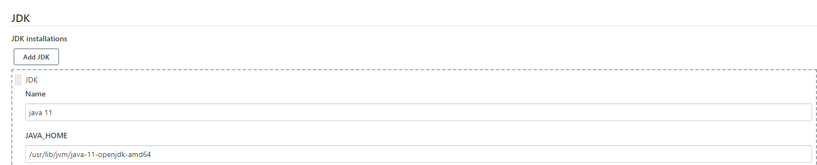

Maven:

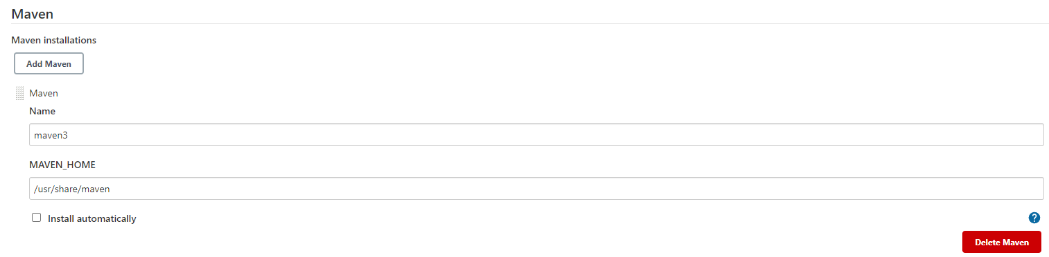

Created new pipeline with name “Project1Build”

Select SCM as git and added credentials

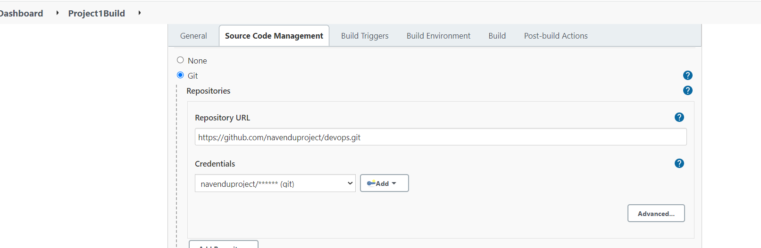

Under Build, select “Top level Maven targets”:

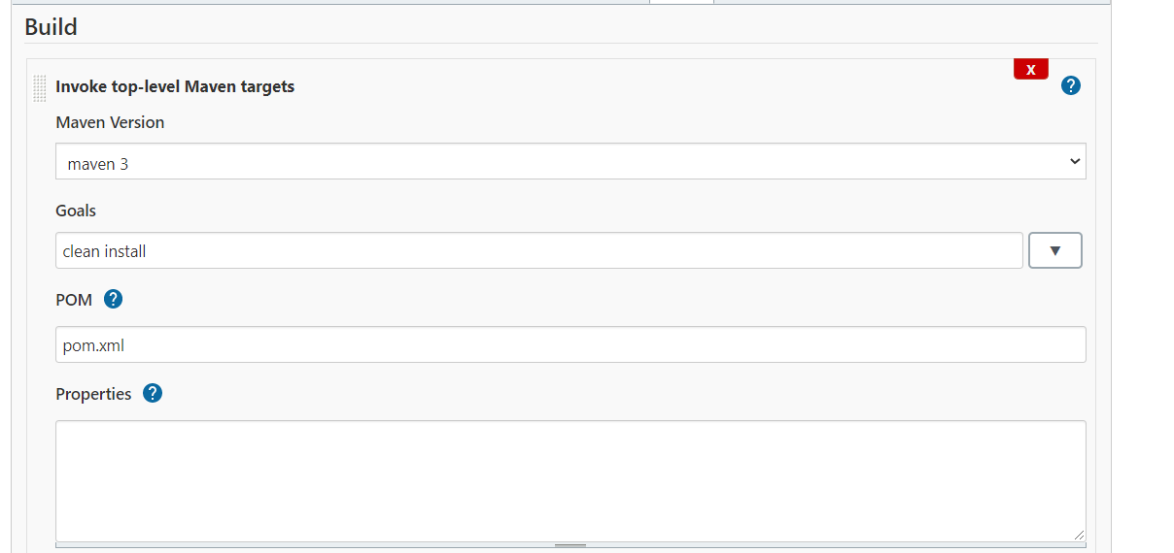

Add “Execute shell” build step to ensure the permission for group is constant even after server reboot

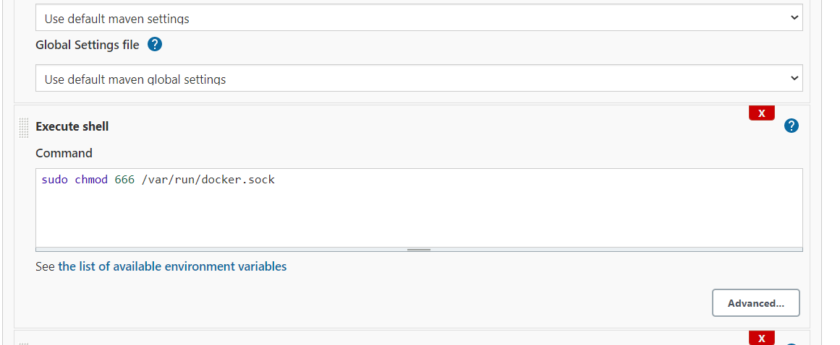

Add another Build step and select “Docker Build and Publish”

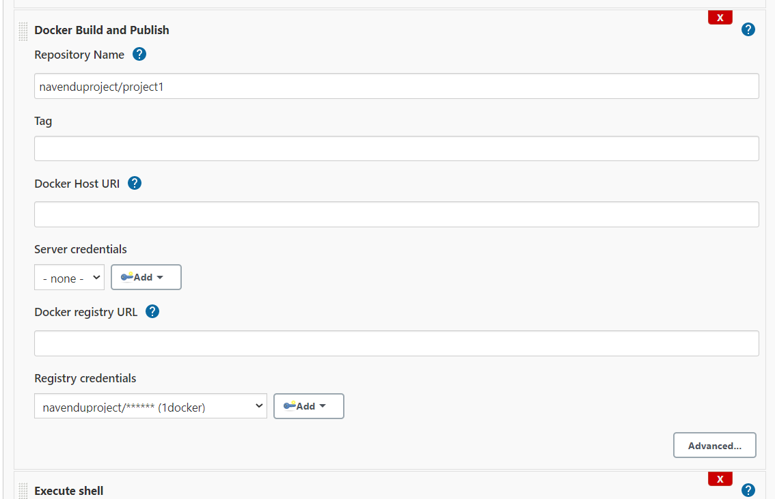

Add a step to remove the image from Ansible server/instance once the image is pushed.

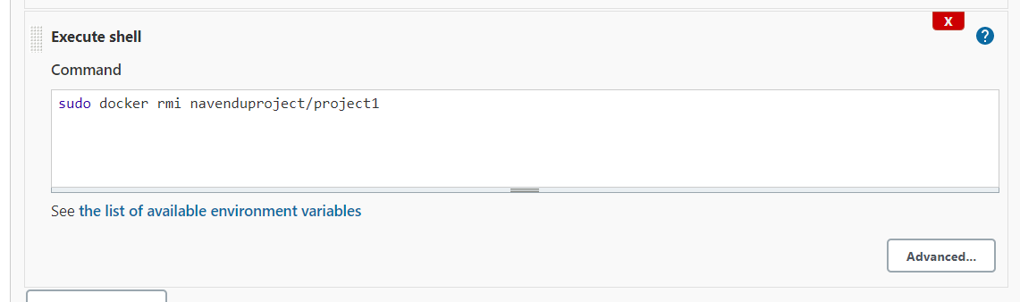

Test Build pipeline by executing it:

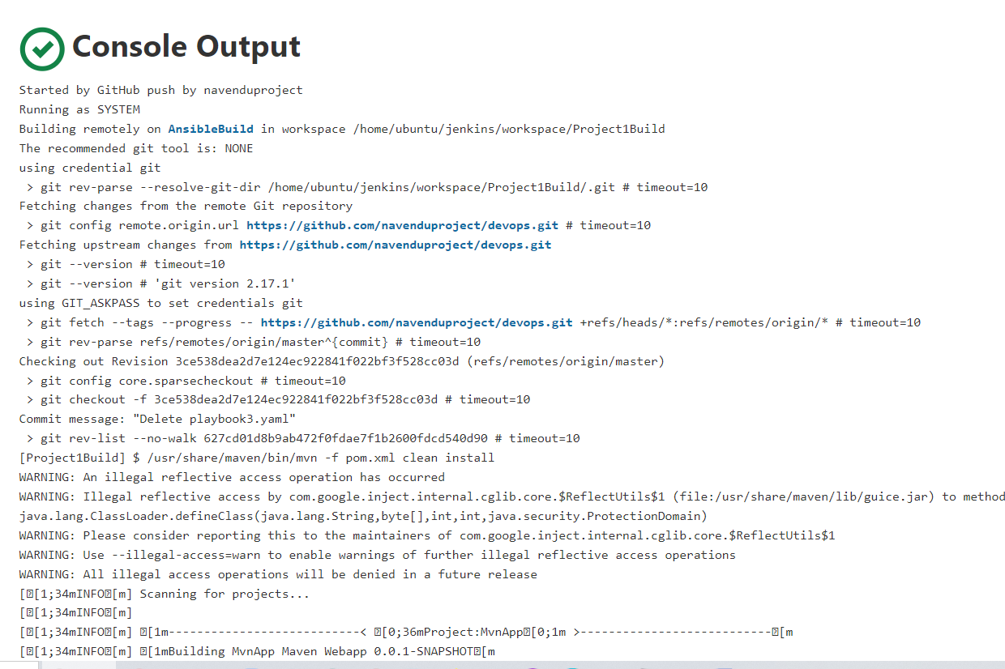

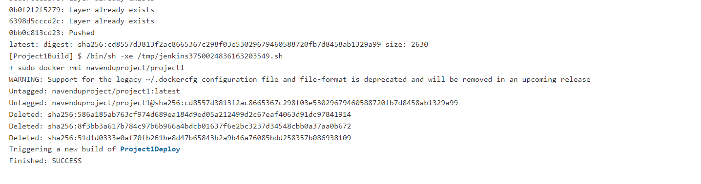

Project1Build pipe was successful and triggered is pushed to Docker repo successfully

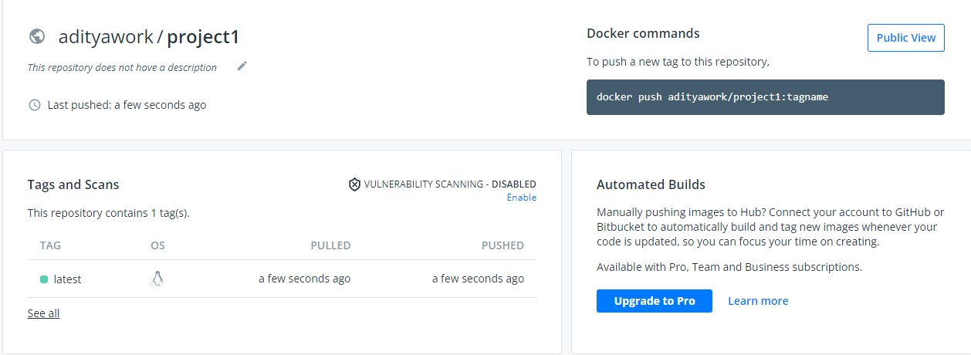

Create pipeline with name Project1Deploy

Configure SCM

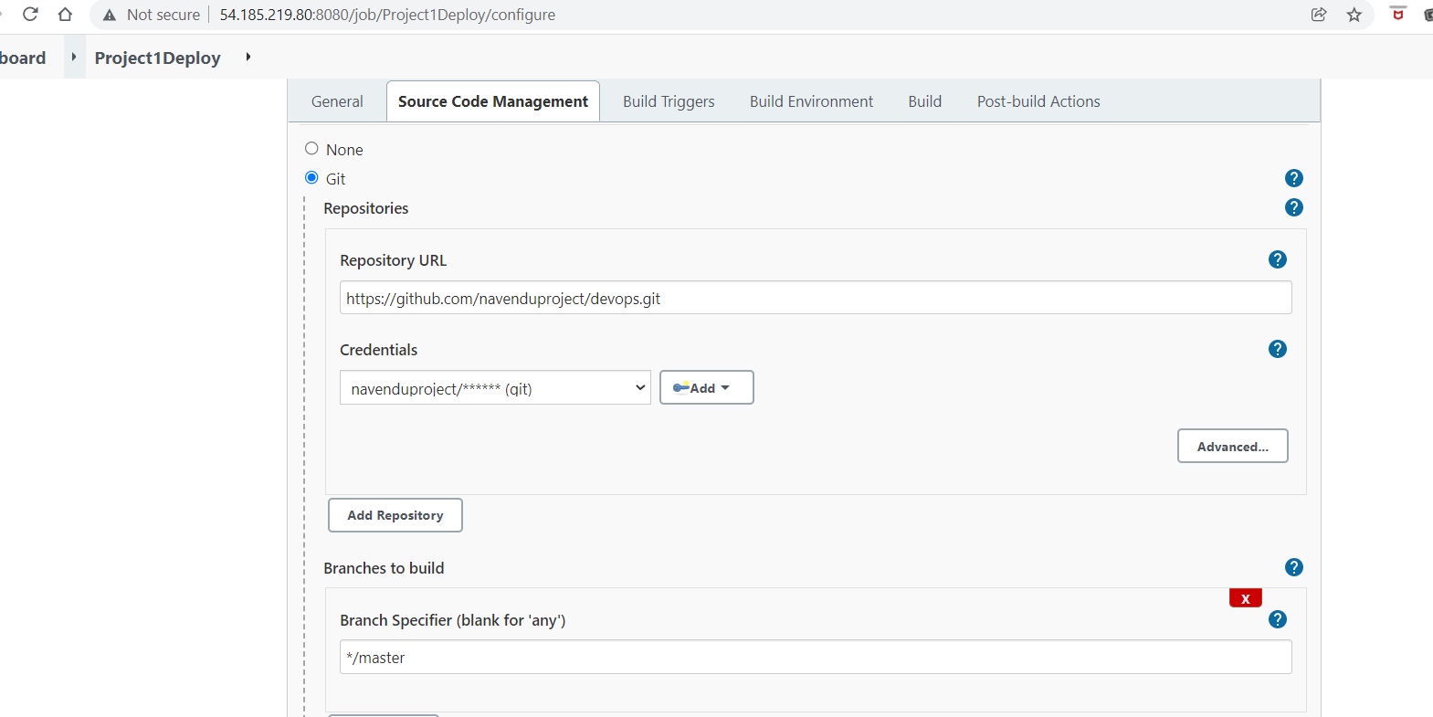

Build trigger to start after Project1Deploy Pipeline automatically after Project1Build pipeline is completed successfully

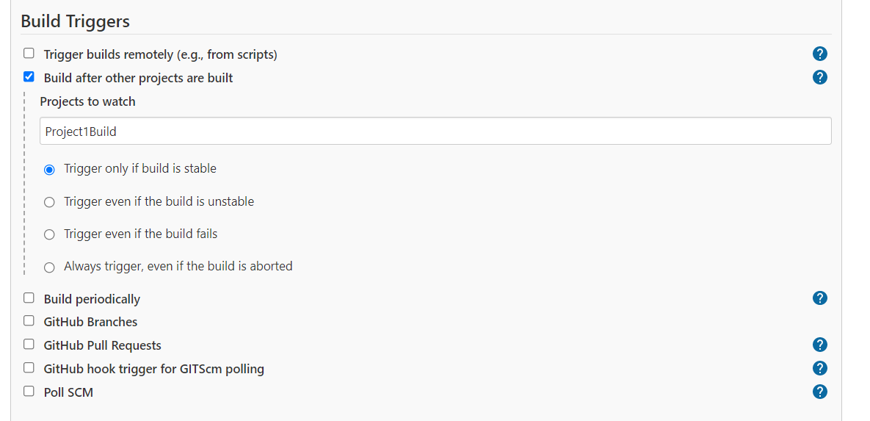

Add build step to execute shell to change permissions and execute a shell script

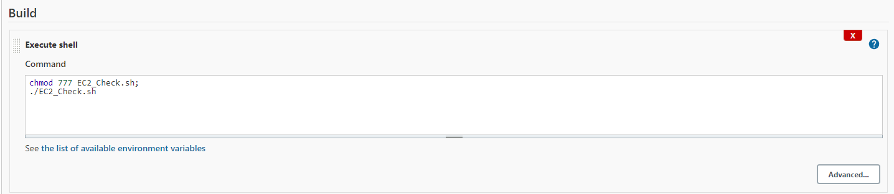

Create Webhook in Github Project1 repository

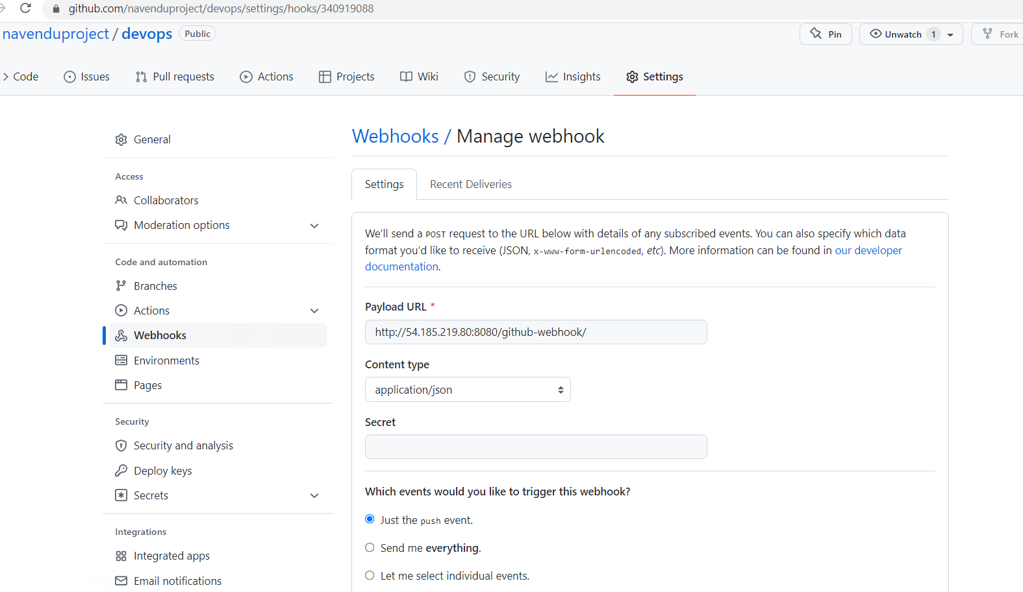

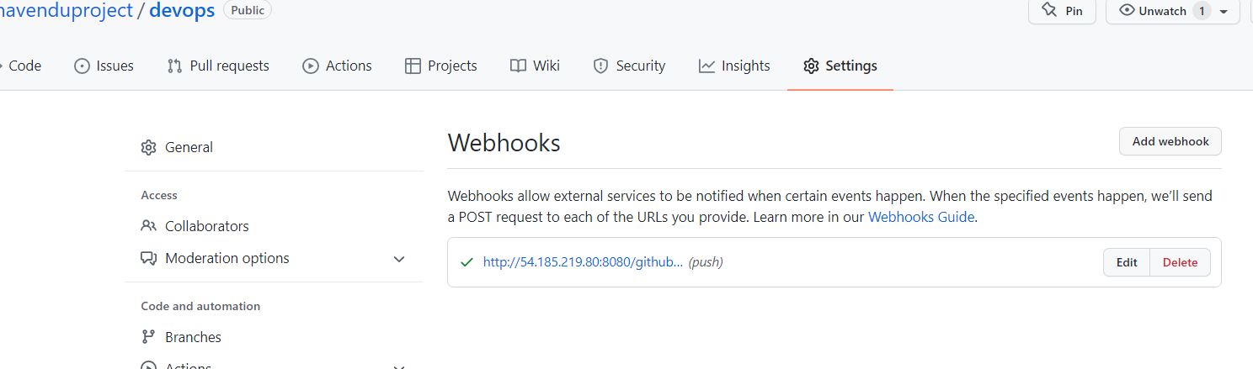

Enable GitHub hook trigger in Build Pipeline :

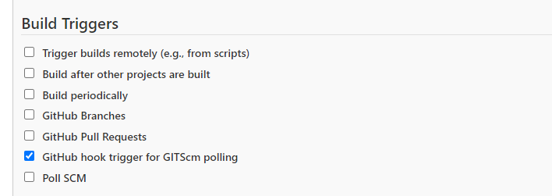

**TESTING**

On Jenkins:

Pipelines:

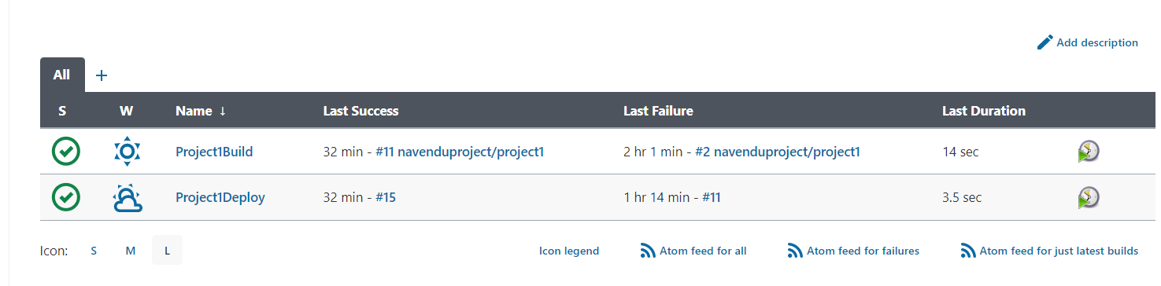

Nodes:

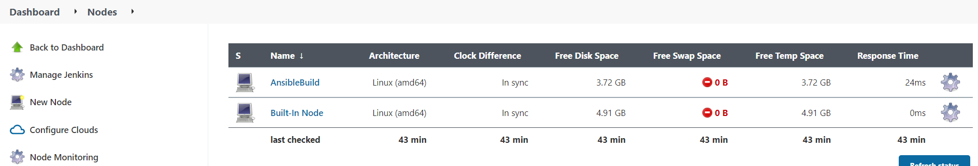

May a change & committed in the GIT repository to index.jsp

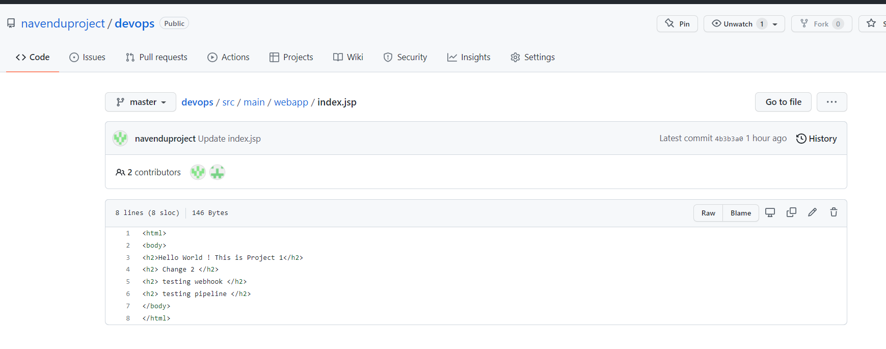

Project1Build pipeline should be triggered automatically on Jenkins:

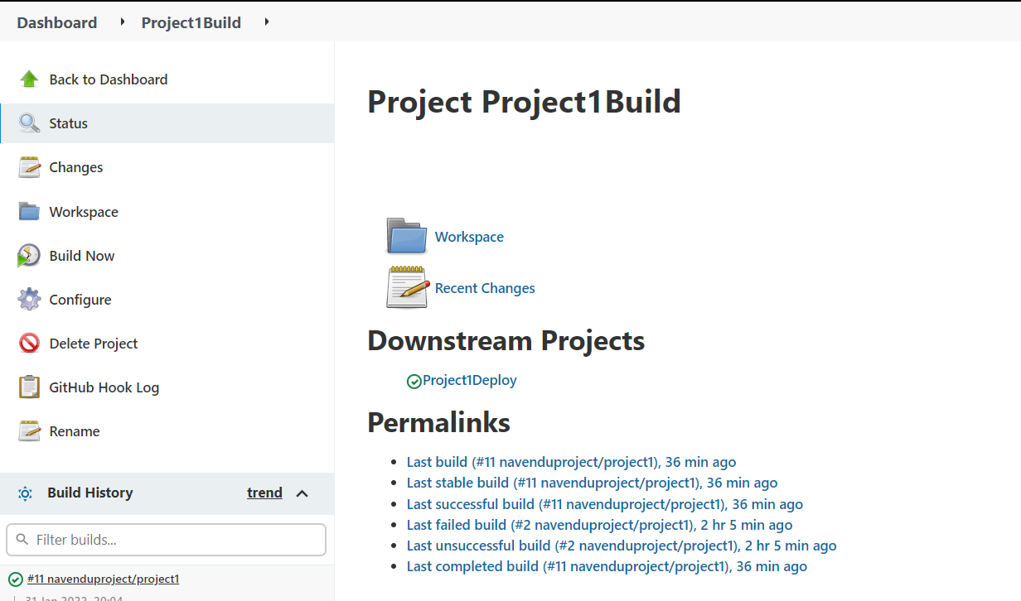

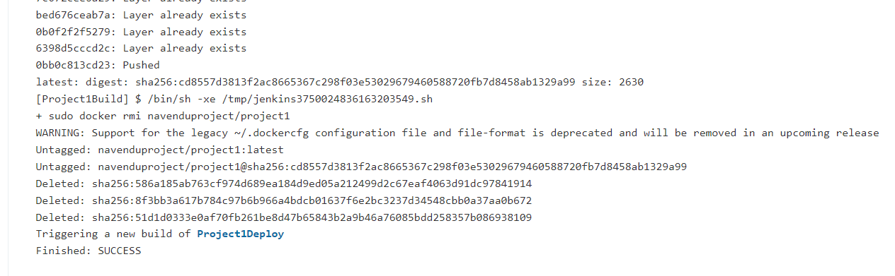

Project1Build pipeline triggers Project1Deploy pipeline once completed successfully:

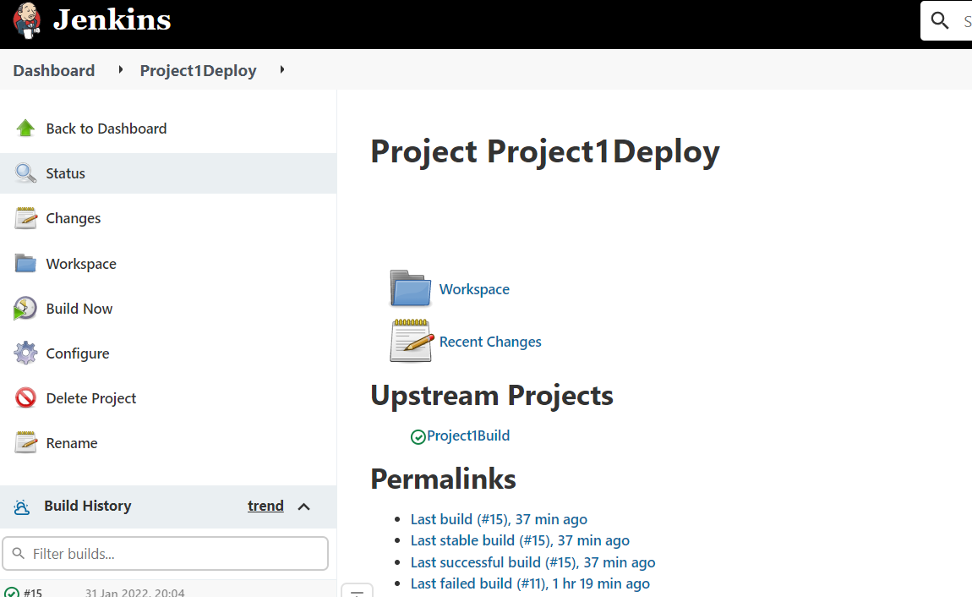

Logs from Project1Deploy pipeline :

